**Notes**

**Day 16: intro to oop**

* We have attributes and methods in OOP
* Attributes are variables
* Methods are functions
* Pretty table can be used to make tables

**Day 17: oop advanced**

* Make a class like: class {class_name}:…
* Standard way to name the class in python is by using beginning of each word capitalized (i.e. first letter of each word).
* Constructor: tells what should happen when our object is being construct and is built by __init__(self).
* We can add the parameters to initialize the values in that function e.g.:

class User:  
 def __init__(self, user_id, username, followers):  
 self.user_id = user_id  
 self.username = username  
 self.followers = 0

* **Attributes:** are the things that the object have
* **Methods:** are the things that the object does
* A method always need to have a parameter as the first parameter always
* When you assign class to a variable and make it an object, it need have parenthesis at the end e.g. user = User()

**Day 18: comprehensive guide on using documentation and games with turtle graphics**

* Turtle documentation link: <https://docs.python.org/3/library/turtle.html>
* You need learn the way documentations are read, so, you should not depend on other people all the time
* From turtle import Turtle means “keyword Module keyword (thing in module)”
* This way of using from is way more convenient. By writing “*” instead of (thing in module), it is more convenient at times since we can import everything from that although not recommended.
* import turtle as t means “keyword module keyword alias_name” which can come in handy especially when there are very large module names
* You can download new packages and install new packages by “Python Interpreter Setting -> click on ‘+’ sign -> name the package”.

**Day 19: Event Listeners and more games using turtle graphics and more**

* We generally don’t pass a function with parenthesis as an argument in another function because that means it should get triggered then and their
* **Higher Order Functions:** Functions that can work with other functions e.g.:

def add(n1, n2):  
 return n1 + n2  
  
def calculator(n1, n2,func):  
 return func(n1, n2)  
  
result = calculator(2, 3, add)  
print(result)

*So, here basically calculator is higher order function which is working with add() function coming in it as a parameter.*

This can particularly be done in python and in my programming languages it can’t be done

* **State:** Each object have different attributes and can be performing different methods at any time

**Day 20: Snake Game half**

**Day 21 & 22: Snake Game and OOP and some more concepts**

* **Class inheritance:** inherit the attributes and methods of the previous class so you don’t need to write them again e.g.

class Animal:  
 def __init__(self):  
 self.num_of_eyes = 2  
   
 def breathe(self):  
 print("Inhale and exhale")  
  
class Fish(Animal): # Here we have inherited the class "Animal"  
 def __init__(self):  
 super().__init__()  
   
 def breathe(self):  
 super().breathe()  
 print("doing this underwater")  
   
 def swim(self):  
 print("moving in water")  
   
fish = Fish()  
fish.num_of_eyes  
fish.breathe()  
fish.swim()

**Day 23: Turtle Crossing Game – Capstone Project**

**Day 24: Files, Directories and Paths**

* **Working Directory:** Place where you are working currently (folder)
* **Relative Path:** Location of the file in relative to your working directory
* **Absolute Path:** Location of the file from root folder

with open(file="my_file.txt") as file:  
 # Read the content of the file  
 contents = file.read()  
 print(contents)  
  
with open(file="my_file.txt", mode="a") as file:  
 # Write content to the file  
 file.write("\nWhere can everyone find him?")  
  
with open(file="new_file.txt", mode="a") as file:  
 # Make new file automatically  
 file.write("Wow!")

**Day 25: Pandas**

* Used to read and analyze csv files

import pandas  
  
data = pandas.read_csv("weather_data.csv")  
  
# Print specified column  
print()  
print(data["temp"])  
  
# Convert data into dictionary  
print()  
data_dict = data.to_dict()  
print(data_dict)  
  
# Convert specified column into list  
print()  
temp_list = data["temp"].to_list()  
print(temp_list)  
  
# Get mean temperature  
print()  
mean_temp_data = data["temp"].mean()  
print(mean_temp_data)  
  
# Get max temperature  
print()  
max_value = data["temp"].max()  
print(max_value)  
  
# Get specified in two different ways  
print()  
print(data["condition"])  
print()  
print(data.condition)  
  
# Get data in row  
print()  
print(data[data.day == "Monday"])  
print()  
print(data[data.temp == max_value])  
  
# Convert Monday's temperature from Celsius to Fahrenheit  
print()  
monday = data[data.day == "Monday"]  
print((monday.temp * (9/5)) + 32)  
  
# Making DataFame from dictionary  
data_dict = {  
 "students": ["Amy", "James", "Angela"],  
 "scores": [76, 56, 65]  
}  
data = pandas.DataFrame(data_dict)  
print(data)  
  
# Convert this dictionary in csv file and store it at the specified location  
data.to_csv("new_data.csv")

**Day 26: List Comprehension and NATO Alphabet**

* To loop through pandas DataFrame:

import pandas  
student_dict = {"student": ["Angela", "James", "Lily"], "score": [56, 76, 98]}  
student_data_frame = pandas.DataFrame(student_dict)  
  
for (index, row) in student_data_frame.iterrows():  
 print(index)  
 print(row)  
 print(row.student)  
 print()

**Day 27: Tkinter, *args, **kwargs, and Creating GUI Programs**

* Initializing and setting up tkinter

import tkinter  
  
windows = tkinter.Tk()  
windows.title("My First GUI Program")  
windows.minsize(width=500, height=300)  
  
windows.mainloop()

* To make a label and print something on the screen, you use **tkinter.Label()** and **.pack()** method to display it on the screen e.g.

# Label  
my_label = tkinter.Label(text="I am not a label", font=("Arial", 24, "bold"))  
my_label.pack()

* **Advanced Arguments:**
  + There are default values of the arguments also when we can assign when creating
  + We can place **\*args** in the parameter which will allow us to pass as many arguments as we want when calling the function e.g.
  + def add(*args):  
     ans = 0  
     for i in args:  
     ans += i  
     print(ans)  
      
      
    add(3, 5, 6)
  + Passing this **\*args** is known as **Unlimited Arguments** or **Unlimited Positional Arguments**.
  + **\*\*kwargs** is known keyword arguments and if we pass the arguments with their name, it will be passed as the dictionary e.g.
  + def calculate(n, **kwargs):  
     print(kwargs)  
     n += kwargs["add"]  
     n *= kwargs["multiply"]  
     print(n)  
      
      
    calculate(2, add=3, multiply=5)
* We can change the arguments values *tkinter* by following 2 ways:
  + my_label["text"] = "New Text"  
    my_label.config(text="New Text")
* We can make buttons by using **Button()** class from tkinter:
  + def button_clicked():  
     print("I got clicked!")  
     my_label.config(text="I got clicked")  
      
      
    button = Button(text="Click me!", command=button_clicked)  
    button.pack()
* We can get input from the user by using **Entry()** class:
  + def button_clicked():  
     print("I got clicked!")  
     my_label.config(text="I got clicked")  
     new_text = user_input.get()  
     my_label.config(text=new_text)
  + user_input = Entry(width=10)  
    user_input.pack()  
    print(user_input.get())
* **.pack()** method can be used to print anything we do with the program and by default it will add the elements on top
* Some more functions of tkinter are:

# Spinbox  
def spinbox_used():  
 print(spinbox.get())  
  
  
spinbox = Spinbox(from_=0, to=10, width=5, command=spinbox_used)  
spinbox.pack()  
  
  
# Scale  
def scale_used(value):  
 print(value)  
  
  
scale = Scale(from_=0, to=100, command=scale_used)  
scale.pack()  
  
  
# Checkbutton  
def checkbutton_used():  
 print(checkbutton_state.get())  
  
  
checkbutton_state = IntVar()  
checkbutton = Checkbutton(text="Is On?", variable=checkbutton_state, command=checkbutton_used)  
checkbutton.pack()  
  
  
# Radiobutton  
def radio_used():  
 print(radio_state.get())  
  
  
radio_state = IntVar()  
# print(radio_state.get())  
radio_button_1 = Radiobutton(text="Option 1", value=1, variable=radio_state, command=radio_used)  
radio_button_2 = Radiobutton(text="Option 2", value=2, variable=radio_state, command=radio_used)  
radio_button_1.pack()  
radio_button_2.pack()  
  
  
# ListBox  
def listbox_used(event):  
 print(listbox.get(listbox.curselection()))  
  
  
listbox = Listbox(height=4)  
fruits = ["Apple", "Pear", "Orange", "Banana"]  
for item in fruits:  
 listbox.insert(fruits.index(item), item)  
listbox.bind("<<ListboxSelect>>", listbox_used)  
listbox.pack()

* **.place()** can be used to place the object at precise positions unlike “.pack()”
* Drawback for this method is that, you have to figure out the precise co-ordinates for every single object e.g. 10 items e.g.

my_label.place(x=100, y=100)

* **.grid()** can be used by specifying the column and row number e.g.

from tkinter import *  
  
  
# Button  
def button_clicked():  
 print("Button got clicked!")  
 my_label.config(text="Button got clicked")  
 new_text = user_input.get()  
 my_label.config(text=new_text)  
  
  
windows = Tk()  
windows.title("My First GUI Program")  
windows.minsize(width=500, height=300)  
  
# Label  
my_label = Label(text="I am not a label", font=("Arial", 24, "bold"))  
my_label["text"] = "New Text"  
my_label.config(text="New Text")  
# my_label.pack()  
# my_label.place(x=100, y=100)  
my_label.grid(column=0, row=0)  
  
# Button  
button = Button(text="Click me!", command=button_clicked)  
# button.pack()  
button.grid(column=1, row=1)  
  
# Entry  
user_input = Entry(width=10)  
user_input.focus()  
user_input.insert(END, "bro")  
# user_input.pack()  
user_input.grid(column=2, row=2)  
  
windows.mainloop()

* To add a little bit of padding to your elements, use **.config()** with parameters **padx** and **pady** e.g.

windows.config(padx=20, pady=20)

**Day 28: Tkinter, Dynamic Typing, and Pomodoro GUI Application**

* **Canvas Widget:** Used to appear objects on the screen alongside some text (if required) e.g.

canvas = Canvas(width=200, height=224, bg=YELLOW, highlightthickness=0)  
tomato_img = PhotoImage(file="tomato.png")  
canvas.create_image(100, 112, image=tomato_img)  
canvas.create_text(103, 130, text="00:00", fill="white", font=(FONT_NAME, 35, "bold"))  
canvas.pack()

* Here, we use **PhotoImage()** for specifying file location for the image.
* **.create_image()** for specifying the image and where it should be placed.
* **.canvsa_create_text()** for specifying the text that should be placed at a specific position
* **highlightthickness=0** will remove the borders or a little of the thickness from the side of the button/label etc.
* When something happen in the GUI Program, something happens, this is called **Event Driven**.
* **window.after** runs after a certain amount specified as the first parameter, second parameter, is the function to run, and the last parameter is *args, values that will be passed into the function.
* **.itemconfig** for canvas can be used to edit the variable’s properties
* **Dynamic Typing** is known as changing data type of the variable.

**Day 29: Building a Password GUI App with Tkinter**

* **.columnspan** as the parameter of *grid* can be used to tell, how many columns the item should take.
* **.join()** can be used to join the string separated by particular character you mentioned after appending every index.
* Following is the code to generate random numbers:

def generate_password():  
 nr_letters = random.randint(8, 10)  
 nr_symbols = random.randint(2, 4)  
 nr_numbers = random.randint(2, 4)  
  
 password_list = []  
  
 password_list = [random.choice(letters) for _ in range(nr_letters)]  
 password_list.extend([random.choice(symbols) for _ in range(nr_symbols)])  
 password_list.extend([random.choice(numbers) for _ in range(nr_numbers)])  
  
 random.shuffle(password_list)  
  
 password = "".join(password_list)  
  
 print(f"Your password is: {password}")

**Day 30: Intermediate - Errors, Exceptions and JSON Data: Improving the Password**

* **Exceptional Handling** is avoiding the errors that are not made while writing the syntax.
* **try…except…else…finally** is the pattern which can be used to handle these exceptions/runtime handling.
* **try:** Something that might cause an exception
* **except:** Do this if there was an exception
* **else:** Do this if there were no exceptions
* **finally:** Do this no matter what happens
* **Errors with “Except”:**
  + **FileNotFoundError:** When file does not exist
  + **KeyError:** When a key does not exist in the dictionary
* Using **“as”** alongside **“error_message”** means you are catching the message which caused that error
* Example of the code e.g.:

try:  
 file = open("a_file.txt")  
 addict = {"key": "value"}  
 print(a_dict["key"])  
except FileNotFoundError:  
 file = open(file="a_file.txt", mode="w")  
 file.write("Something")  
except KeyError as error_message:  
 print(f"The key {error_message} does not exist")  
else: # Runs when all lines in the try block run  
 content = file.read()  
 print(content)  
finally:  
 file.close()  
 print("File was closed")

* You can also raise an exception by using **raise** keywork e.g.

raise KeyError("I made this up")

* It can be used for example when there could be a logic error e.g. exceptionally high height or unrealistic weight entered
* **JSON:** It is basically storing the data in key-value pairs in a dictionary instead of a text file which makes it easier to understand and extract or manipulate the data
* **indent:** can be used to make the data more human readable
* Code for writing the data in the JSON file e.g.

import json

with open(file="data.json", mode="w") as file: # This way you can write the data  
 json.dump(new_data, file, indent=2)

* Code for reading the data from the JSON file e.g.

with open(file="data.json", mode="r") as file: # This way you can read the data  
 data = json.load(file)

* Code for updating the data in the JSON file e.g.

with open("data.json", "r") as data_file:  
 # Reading old data  
 data = json.load(data_file)  
  
 # Updating old data with new data  
 data.update(new_data)  
  
with open(file="data.json", mode="w") as file: # This way you can write the data  
 # Saving updated data  
 json.dump(data, file, indent=2)

**Day 32: Send Email (SMTPLIB) & Manage Dates (datetime)**

* **SMTP (Simple Mail Transfer Protocol):** All the rules that determine how email is received by mail servers, passed onto the mail servers and how it is sent across the internet
* Declare an object with .smtp and tell your host e.g. for Gmail, it is “smtp.gmail.com”, for Yahoo, it is “smtp.mail.yahoo.com”, and for Hotmail, it is “smtp.live.com”. For other providers, search google for the info. Code e.g.

import smtplib  
  
my_email = "hellomy98d@gmail.com"  
  
connection = smtplib.SMTP(host="smtp.gmail.com")

* By using “connection.starttls()”, we can secure our connection where tls stands for “Transport Layer Security”.
* My [hellomy98d@gmail.com](mailto:hellomy98d@gmail.com) password: aeyzoterumrnhoux
* Following code can be used to send the email:

import smtplib

my_email = "hellomy98d@gmail.com"

password = "aeyzoterumrnhoux"

with smtplib.SMTP(host="smtp.gmail.com") as connection:

connection.starttls()

connection.login(user=my_email, password=password)

connection.sendmail(from_addr=my_email,

to_addrs="ninjacombo99@gmail.com",

msg="Subject:Hello!\n\nThis is the body of my email")

* “Subject” gives the subject of the email and double “\n” is used to type down the body
* Your “host” also needs to be correct.
* **DateTime** module can be used to check current date, day, month, weekday, and etc e.g.

import datetime as dt

datetime = dt.datetime.now()

print(datetime.year)

print(datetime.month)

print(datetime.weekday())

print(datetime.day)

date_of_birth = dt.datetime(year=2004, month=7, day=21)

print(date_of_birth)

* **PythonEverywhere** can be used to run the code every single day, link: <https://www.pythonanywhere.com>

**Day 33: API Endpoints & API Parameters - ISS Overhead Notifier**

* **Application Programming Interface (API):** is a set of commands, functions, protocols, and objects that programmers can use to create software or interact with an external system.
* API is a barrier between your program and external system and you need to make proper request to access it with the rules that should be followed and the external system will respond you appropriately.
* **Some response codes:**
  + 1XX: Hold On
  + 2XX: Here You Go
  + 3XX: Go Away
  + 4XX: You Screwed Up
  + 5XX: I Screwed Up
* To check the response code, use **.status_code** with the variable you have stored the request in e.g.

import requests  
  
response = requests.get(url="http://api.open-notify.org/iss-now.json")  
if response.status_code != 200:  
 raise Exception("Bad response from ISS API")

* You can use raise for status to raise the **Exception** in case there is an exception:

response.raise_for_status()

* Code for API e.g.

import requests  
  
response = requests.get(url="http://api.open-notify.org/iss-now.json")  
response.raise_for_status()  
  
data = response.json()  
  
longitude = data["iss_position"]["longitude"]  
latitude = data["iss_position"]["latitude"]  
  
iss_position = (longitude, latitude)  
  
print(iss_position)

* If we need a parameter for an API, it can happen either of the two ways:
  + We can pass a parameter named **params=** and specify them as a dictionary, or
* Pass it in the URL as **“Endpoint?ParamValue=Value&…”**

**Day 34: API Practice – Creating a GUI Quiz App**

* To convert the data from html type of data to human readable, you can use “freeformatter”.
* We can even declare a variable as its datatype e.g.:

num: int

* We can also declare the datatype in a function e.g.:

def __init__(self, quiz_brain: QuizBrain, num: int):

* You can also use arrow to expect a datatype of a function e.g.:

def next_question(self) -> str

**Day 35: Keys, Authentication & Environment Variables: Send SMS**

* Until now, we were with simple APIs that’s why, we didn’t need to authenticate them.
* By using Twilio API, we can send SMS
* You need to use **os**, **twilio http** to run it on **pythoneverywhere** e.g.

import requests  
import os  
from twilio.rest import Client  
from twilio.http.http_client import TwilioHttpClient  
  
proxy_client = TwilioHttpClient()  
proxy_client.session.proxies = {'https': os.environ['https_proxy']}  
OWN_ENDPOINT = "https://api.openweathermap.org/data/2.5/onecall"  
api_key = "08341857fd4d92a3cca11b5cff0bad47"  
account_sid = "AC4b7d48aea7790f6fc7136aeb0c33a7f3"  
auth_token = "adb52eab098b5feeeaf7e1698f2ffff8"  
will_rain = False  
  
weather_params = {  
 "lat": 24.860735,  
 "lon": 67.001137,  
 "exclude": "current,minutely,daily",  
 "appid": api_key  
}  
  
response = requests.get(OWN_ENDPOINT, params=weather_params)  
data = response.json()  
weather_slice = data["hourly"][:12]  
for hour_data in weather_slice:  
 condition_code = int(hour_data["weather"][0]["id"])  
 if not will_rain and condition_code < 700:  
 will_rain = True  
  
if will_rain:  
 print("Bring an Umbrella")  
 client = Client(account_sid, auth_token)  
 message = client.messages.create(  
 body="Shut Up",  
 from_="+13159034687",  
 to="+923218050206"  
 )  
  
client = Client(account_sid, auth_token)  
message = client.messages.create(  
 body="Take umbrella or shut up",  
 from_="+13159034687",  
 to="+923218050206"  
)

* **Environment Variables** allows our code to be stored separately just as we want e.g. auth_token

api_key = os.environ.get("OWM_API_KEY")

**Day 36: Stock Trading News Alert Project**

* Capstone Project?
* Done !

**Day 37: Habit Tracking Project: API Post Requests & Headers**

* We can import html and use .unescape() method to convert the html text in a string.
* We can use re library to remove commands e.g.

import html

import re

regex = re.compile(r'<[^>]+>')  
  
  
def remove_html(string):  
 return regex.sub('', string)

article_data += f"Headline: {html.unescape(i['title'])}\n"  
article_data += f"Brief: {html.unescape(i['description'])}\n\n"  
article_data = remove_html(article_data)

* We can use four methods with HTTP library i.e. GET, POST, PUT, and DELETE.
* For **GET**, we use **requests.get()**
* For **POST**, we use **requests.post()**
* For **PUT**, we use **requests.put()**
* For **DELETE**, we use **requests.delete()**
* In **get request**, we ask the external system for a piece of data.
* In **post request**, we give external system some data e.g. saving data in *Google Sheets* or *post a tweet*.
* In **put request**, we update a piece of data like updating some data in a spreadsheet
* In **delete request**, we can delete the data e.g. tweet.
* We can use **json=** as a parameter in **requests.post** e.g.

response = requests.post(url=PIXELA_ENDPOINT, json=user_params)

* **“Header”** is like title or logo, while **“Body”** is where the rest of the data comes in. We can pass it like this:

response = requests.post(url=GRAPH_ENDPOINT, json=graph_endpoint_json, headers=graph_endpoint_headers)

* We can use .**strftime** to get date in specific format e.g.

current_date = datetime.now()

current_date = current_date.strftime("%Y%m%d")

**Day 38: Workout Tracking Using Google Sheets**

* Completed!

**Day 39: Capstone Part 1: Flight Deal Finder**

* Completed!

**Day 40: Capstone Part 2: Flight Club**

* Completed!

**Day 41: Web Foundation - Introduction to HTML**

* Internet works by: Client sends the request to ISP (Internet Service Provider), which find the DNS server of the web from DNS database
* That response will be loaded in your computer and you will send a direct request to the Server via ISP
* Internet backbone is all the underwater submarine cables.
* The response is then loaded into your computer e.g. <https://www.google.com>
* HTML is used for the **structure**, CSS for **styling**, and JavaScript for **functioning**.
* From **<h[1-6]>** is used to specify headings.
* Most of HTML tags having a closing tag also e.g. <h1>Title here</h1>
* **<br>** is used to break the line or give a line break
* **<startingTag>Content</closingTag>**
* Tags that do not require a closing tag are known as **self-closing tag**.
* **<hr>** is used to draw a horizontal line. *Attributes* it can have are **size** and **noshade** etc e.g.

<hr size="3" noshade>

* **<tag Attribute=valueIfRequired></closingTagIfRequired>**
* **HTML Boiler Plate** is the code that can be used over and over again.
* **<!DOCTYPE html>** is used to render the latest html 5 boiler plate.
* **<head>** tells the browser what to do about the website e.g. its title
* **<meta charset="UTF-8">** is used to encode the characters to make it more secure.
* **<body>** is where you build all the structure of the website.
* **<p>** is used to output the paragraph.
* **<i>** vs **<em>** and **<b>** vs **<strong>** where *<em>* and *<strong>* is more recommended to use since they have more meaning.
* **<ul></ul>** (unordered list) or **<ol></ol>** can be used to make lists in the website, you can use e.g. **type** in *<ol>*
* **<li></li>** is used to define every point.
* **<img src=”path” alt=””>** is used to print the image on the website, **alt** is used to describe the alternative text in case the image is not there.
* **<a href=”” target=””>***Text***</a>** is used to define the hyperlink to certain text. **href** is the link, **target** is where you would like it to open e.g. **“_blank”**.

**Day 42: Web Foundation - Intermediate HTML**

* **<table border></table>** can be used to make the table.
* **<tr></tr>** for table row.
* **<td></td>** for table cell
* **<th></th>** for table heading in bold
* **<thead></ thead>** to define table heading structure e.g.

<table border>

<thead>

<tr>

<th>Dates</th>

<th>Work/Problem</th>

</tr>

</thead>

<tr>

<td>2022-2023</td>

<td>Expert in AI and Data Science</td>

</tr>

<tr>

<td>2022-2023</td>

<td>L4 L5 problem</td>

</tr>

</table>

* **cellspacing** attribute can be used in **<table>** to define the spacing between two cells.
* **<form></form>** is used to make forms to take user input
* **<label></label>** which is written within **<form></form>**, we can mention what we want
* **<input>** *(self-closing tag)* used within **<form></form>** can be used to take the appropriate input e.g.

<form action="index.html" method="post">

<label>Your Name:</label>

<input type="text">

<input type="color"><br>

<label>Your password:</label>

<input type="password"><br>

<input type="file"><br>

<input type="date"><br>

<input type="radio"><br>

<input type="range"><br>

<input type="submit" value="Submit">

</form>

* **<textarea></textarea>** can be used to get large inputs

<textarea name="name" cols="30" rows="10"></textarea><br>

* We can use [**mailto:[mentionemail]**](mailto:[mentionemail]) as an action in form where when you click submit, it will redirect you to Gmail.
* **enctype=”text/plain”** is another attribute for form to get plain text when redirected to Gmail.
* Also, if the action is set to **“index.html”**, it will re-direct you to that certain page.

**Day 43: Web Foundation - Introduction to CSS**

* To edit the styles of the file, we can use **“Internal CSS”** within html file e.g.

<style>

        body {

            background-color: #ECF2FF;

        }

        hr {

        background-color: white;

        border-style: None;

        height: 2px;

        width: 100px;

        }

</style>

* A better way to do so is by using external CSS and linking to it e.g. in html:

<link rel="stylesheet" href="/styles.css">

* in CSS:

body {

            background-color: #ECF2FF;

}

hr {

border-style: None;

border-top-style: dotted;

border-width: 7px;

border-color: #E8E2E2;

width: 10%;

}

* The priority goes like this tag properties/inline CSS > internal CSS > external CSS.
* Format for CSS styling: **selector {property: value;}**.
  + Selector is who?
  + Property is what?
  + Value is how?
* **Class** attribute in any tag allows us to style that specific element e.g.

<img class="bbq" src="/images/meat.png" alt="bbq-img"><br>

* To target a class in CSS we use **“.”** e.g.

.bbq {

    border: solid;

    border-width: 5px;

    border-color: #3E54AC;

}

* **Id** selector can be used similar to class e.g.

<img class="bbq" id="bbq_id" src="/images/meat.png" alt="bbq-img"><br>

* But it is called with **“#”** in CSS
* **Id has the highest priority of all because it is very specific.**
* “Classes” can be same for multiple tags but “ids” can only be used once.
* A CSS pseudo-class is a keyword added to a selector that specifies a special state of the selected element(s). For example, the pseudo-class :hover can be used to select a button when a user's pointer hovers over the button and this selected button can then be styled e.g. **“a:hover**

**Day 43 & 44: Web Foundation - Intermediate CSS**

* We can icons as property for applying **favicons** to our website and favicons are a little tiny symbol that shows up before the text on the tab e.g.

<link rel="icon" href="favicons/worker.png">

* **<div></div>** allows us to structure our website separately.
* **Div** stands **content division element** e.g.

<div class="top-container">

        <img src="images/cloud.png" alt="cloud-img">

        <h1>I'm Salman</h1>

        <p>an AI/DataScietist</p>

        <img src="images/cloud.png" alt="cloud-img">

        <img src="images/mountain.png" alt="mountain-img">

</div>

* We have default rules for elements.
* **Box Model:** It is a model in which, we have widths and heights defined e.g. width: 100% or width: 600px.

border-width: 0px 10px 20px 30px;

* Above line means that 0px is for top, 10px for right, 20px for bottom, and 30px for left (circle)
* **Margin:** Gives us space between the elements outside the border
* **Padding** on the other hand gives us space with in the border.
* **CSS Display Property:** It’s the property that contains four types:
  + **Block:** Takes an entire line
  + **Inline:** Takes just enough space
  + **Inline-Block:** Same as inline but it also respects other things and at the same time e.g. padding
  + **None:** Gets rid of that element.
* **<span></span>** can be used to styling an element e.g.

<p>an <span>AI</span>/DataScietist</p>

* You can use **visibility: hidden;** in CSS instead of **None** since it will not pretend to be invisible and take space although you cannot see it.
* **CSS Positioning:**
  + Content is everything.
  + Order comes from code.
  + Children sit on parents.
* 4 ways to change **position** property:
  + **Static:** All elements are static in their position by default.
  + **Relative:** Position the element relative to its static position. *Other elements doesn’t get affected*. Four common co-ordinate properties:
    - **Top**
    - **Right**
    - **Bottom**
    - **Left**
  + **Absolute:** Fixed in relation to the parent element, remove it from the flow.
  + **Fixed:** A fixed position element is positioned relative to the viewport, or the browser window itself. The viewport doesn’t change when the window is scrolled, so a fixed positioned element will stay right where it is when the page is scrolled.
  + **Sticky:** Sticky positioning is really unique! A sticky element will just sit there like a static element, but as you scroll past it, if it’s parent element has room (usually: extra height) the sticky element will behave as if it’s fixed until that parent element is out of room.
* To align everything in the center, use **text-align: center;** in CSS in the parent or top element that doesn’t have a width set e.g.

body {

    margin: 0px;

    text-align: center;

}

* Another way is this: **margin: 0 auto 0 auto;** or **margin: 0 auto;**
* **font-family: sans-serif;** can be used to change the font of the writing.
* You can get new texts from <https://fonts.google.com> and use it to get the fonts you would like.
* You can change the font size by **font-size: 90px;**
* There are other ways also e.g. you can use **“%”** instead of **“px”**, and it will scale it to the size compared to that of the browser.
* You can also use **“em”** and it will scale the size of the browser.
* **px** is static while **em** and **%** is dynamic.
* **“rem”** is also dynamic and it is the best one since it will scale the size according to the size of the browser while **em** or **%** will scale according to the size set for the parent of our element.
* **float: left;** can be used to put the text or the elements to the left of the image.
* **Clear: left;** can be used to remove the text from floating it at the left/right of the image.
* Other way to do it which is more proper is flexbox.

**Day 45: Web Scraping with Beautiful Soup**

* **Web Scraping:** We look at the information we want and scrape it from HTML Code since APIs doesn’t allow us to do everything we want to do or some websites may not have an API.
* **Beautiful Soup:** Taking out the code from HTML Code.
* We use bs4 library for BeautifulSoup. When declaring it, first parameter is markup that is the content that we are going to use. Second is, the parser that explains what extension the file is e.g.:

from bs4 import BeautifulSoup  
  
with open("website.html", encoding="utf8") as file:  
 contents = file.read()  
  
soup = BeautifulSoup(markup=contents, parser="html.parser", features="lxml")  
print(soup.title)

* To get all the anchor tags or p tags or any else tag, we can do this:

all_anchor_tags = soup.find_all(name="a")

* To get the text:

for tag in all_anchor_tags:  
 print(tag.getText())

* To get any attribute:

print(tag.get("href"))

* To get any object with their specific id or class (you can also use **find_all**):

heading = soup.find(name="h1", id="name")  
print(heading)  
  
section_heading = soup.find(name="h3", class_="heading")  
print(section_heading)

* *Since class is a special keyword used to declare classes, hence, we use* ***“class_”***.
* To narrow down our searches, we can use parent and siblings classes:

company_url = soup.select_one(selector="p a")

print(company_url)

* To select an id or a class:

select_id = soup.select_one(selector="#name")  
print(select_id)  
  
select_class = soup.select(selector=".heading")  
print(select_class)

* To get the html code from the website there are two methods:

import requests  
  
response = requests.get(url="https://news.ycombinator.com/news")  
yc_web_page = response.text

* If you come across a website that has an API and matches your need, always use it.
* To see what is and what is not, type “robots.txt” at the end of the website to see which scraping is allowed and which is not e.g. <https://www.linkedin.com/robots.txt>

**Day 46: Create a Spotify Playlist using the Musical Time Machine**

* Done!

**Day 47: Create an Automated Amazon Price Tracker**

* You can use get your browser data via this website: <https://myhttpheader.com>
* Done!

**Day 48: Selenium Webdriver Browser and Game Playing Bot**

* Our chrome driver is saved at the location: “C:\Development”
* Selenium is better than BeautifulSoup since it can be used to do searching and do all the other things that the browser can do.
* To initialize the selenium with chrome:

from selenium import webdriver  
  
chrome_web_path = "C:\\Development\\chromedriver.exe"  
driver = webdriver.Chrome(executable_path=chrome_web_path)

* To open a website, you can use **“.get(url=)”** method but then also need to close it:

driver.get(url="https://www.amazon.com")  
driver.close()  
driver.quit()

* Here, close() will **only close one tab** while quit will **close the browser**.
* To find an element on a webpage via the use of HTML:

price = driver.find_element(by="class name", value="a-price-whole")  
print(price.text)

* These can be the by values for it:

ID = "id"

NAME = "name"

XPATH = "xpath"

LINK_TEXT = "link text"

PARTIAL_LINK_TEXT = "partial link text"

TAG_NAME = "tag name"

CLASS_NAME = "class name"

CSS_SELECTOR = "css selector"

* Some example codes:

price = driver.find_element(by="class name", value="a-price-whole")  
print(price.text)  
  
search_bar = driver.find_element(by="name", value="q")  
print(search_bar.text)  
  
logo = driver.find_element(by="class name", value="python-logo")  
print(logo.size)

* To get an element by its CSS selector, this works when we can’t find out any other way, we do this:

logo = driver.find_element(by="css selector", value=".documentation-widget a")  
print(logo. Text)

* If nothing works, even CSS selector, then, we use **xpath**:

logo = driver.find_element(by="xpath", value="//*[@id=\"site-map\"]/div[2]/div/ul/li[3]/a")  
print(logo.get_attribute(name="href"))

* If we use find_element**s** instead of find_element, we can get everything that matches the criteria.
* You can click on anything via:

articles_number.click()

* Another way of searching and then clicking:

all_portals = driver.find_element(by="link text", value="All portals")  
all_portals.click()

* To press enter in the search bar, do this:

from selenium.webdriver.common.keys import Keys

search = driver.find_element(by="name", value="search")  
search.send_keys("Python")  
search.send_keys(Keys.ENTER)

**Day 49: Automating Job Applications on LinkedIn**

* To scroll down to a certain element, you can use **“.execute_script”** method and it is the best since it will run even with *exceptions* and do it anyways e.g.

driver.execute_script("arguments[0].scrollIntoView();", all_jobs[x])

driver.execute_script("arguments[0].click();", input_box_field)

driver.execute_script("window.scrollTo(0, document.body.scrollHeight);")

* Sometimes you would to refer the element from the **body** because of its properties continuously changing and you can do it by using CSS selector
* To wait for an execution to perform, you can use **WebDriverWait** e.g.

from selenium.webdriver.common.by import by  
from selenium.webdriver.support import expected_conditions as ec  
from selenium.webdriver.support.wait import WebDriverWait  
from selenium.webdriver.common.keys import Keys

WebDriverWait(driver, 10).until(ec.presence_of_element_located((By.CSS_SELECTOR, ".jobs-search-box__input--location .jobs-search-box__text-input")))

input_box_field.send_keys(Keys.CONTROL + "a")

* In the above code, **“By”** and **“Keys”** method is also used. By can be used to select the type of element you are trying to refer. Keys will do the actions that your keyboard can perform e.g. Key.TAB

**Day 50: Instagram Following Page**

* Sometimes another window will be opened when using *Selenium*, in that case you can use **“.window_handles”** method to select the one you want. You can also use **“.title”** to check if you are on the correct window e.g.

base_window = driver.window_handles[0]  
fb_login_window = driver.window_handles[1]  
driver.switch_to.window(fb_login_window)  
print(driver.title)

* And then switch back:

driver.switch_to.window(base_window)

print(driver.title)

**Day 51: Internet Speed Twitter Complaint Bot**

* Done!

**Day 52: Instagram Follower Bot**

* Done!

**Day 53: Web Scraping Capstone - Data Entry Job Automation**

* Done!

**Day 54: Introduction to Web Development with Flask**

* Flask and Django are used for back-end.
* Flask is for beginners while Django is for large projects
* Back-end is storing data, authenticating etc.
* It has 3 sides:
  + Client-side
  + Server
  + Database

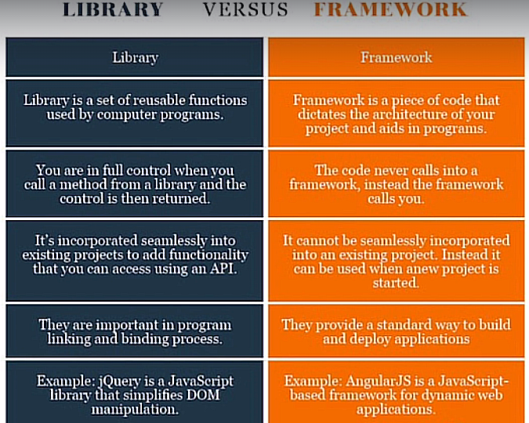

* Don’t name the file same as any library/module.
* Shell is the way to interact with the kernel
* Kernel is the core of the shell
* Shell is the user interface
* You can set a file to an environment variable by using the command in the terminal: **set {VARIABLE_NAME}={file_name}**
* An example code of flask:

from flask import Flask  
  
app = Flask(__name__)  
  
  
@app.route("/")  
def hello_world():  
 return "Hello, World!"  
  
  
if __name__ == "__main__":  
 app.run()

* You can interact with the kernel via the use of GUI/CLI, now we are going to use CLI for this purpose.
* Command line interface will make your things easier comparatively when using flask
* **“pwd”** command in the terminal will tell you the address you are working at
* **“pwd”** stands for *“print working directory”*
* You can use **“cd “{folder_name}””** to get into that folder.
* While writing the folder_name, you can press **tab** which will show you suggestions or directly complete the closest possible folder name for you
* If you use **“ls”**, it will show you all the files and folders in that wd
* **“mkdir {folder_name}”** can be used to make a new directory in that wd
* **type NUL > {file_name}.{extension}** can be used to make new file.
* **copy {file_name_location_to_copy} {location_where_it_should_be_copied}** can be used to copy the from one location to another.
* **del {file_name}** can be used to delete the file/folder.
* **rmdir** **{folder_name}** can be used to delete a folder
* **if __name__ == “__main__”** means that the name of __name__ is equal to __main__, execute the script. E.g. random.__name__ give a name of random.

if __name__ == "__main__":

app.run()

* **Python Decorator** means that a function gives an additional functionality to a function.

def outer_function():

print("I'm outer")

def inner_function():

print("I'm inner")

return inner_function

function = outer_function()

function()

* In the above code, we are storing the nested function in “function” which we can call later to execute that nested function as shown above. Similarly, we can also pass a function without parenthesis as a parameter to call it within the function.

import time

def delay_decorator(function):

def wrapper_function():

time.sleep(2)

# Do something before

function()

function()

# Do something after

return wrapper_function

@delay_decorator

def say_hello():

print("Hello")

# With the @ syntactic sugar

@delay_decorator

def say_bye():

print("Bye")

# Without the @ syntactic sugar

def say_greeting():

print("How are you?")

decorated_function = delay_decorator(say_greeting)

decorated_function()

* In the above code, we are using **“delay_decorator”** as a python decorator, where the function will be first called then the rest.
* If we call say_hello(), it will first run delay_decorator()
* **“@delay_decorator”** is known as **“Syntactic Sugar”**

**Day 55: HTML & URL Parsing in Flask and the Higher Lower Game**

* To name a variable via the use of **“app.route()”**, we can use:

@app.route("/username/<name>")

def greet(name):

return f"Hello {name}"

* Here, **“<name>”** in angular brackets is the variable that will be passed into the function as soon as similar URL will be typed in the browser.
* You need to refresh the server for the changes to get included.
* You can enable the debugger, which activates the automatic reloader, and enables the debug mode on Flask application.
* If the error shows on the website, you can enter the console mode on the website by clicking on that black small icon in that line, and the pin will be at the bottom of the console of the programming language.

@app.route("/<path:name>/<int:num>")

def greet(name, num):

return f"Hello {name}, and {num} years old."

* Here the data before the colon in the path describes the data type e.g. path defines to take entire data after the first slash until int number come.
* You can start using HTML tags via the following way:

@app.route("/")

def hello_world():

return '<h1 style="text-align: center": center">Hello, World!</h1>' \

'<p>This is a paragraph.</p>' \

'<img src="https://media.giphy.com/media/11kXFNRcZBFgwo/giphy.gif" alt="kitten-gif">'

* Code to help understand *python decorators*:

def make_bold(function):

def bold():

return f"<strong>{function()}</strong>"

return bold

def make_italic(function):

def italic():

return f"<em>{function()}</em>"

return italic

def make_underline(function):

def underline():

return f"<u>{function()}</u>"

return underline

* Advanced code of **“*args”** and **“**kwargs”**:

class User:

def __init__(self, name):

self.name = name

self.is_logged_in = False

def is_authenticated_decorator(function):

def wrapper(*args, **kwargs):

if args[0].is_logged_in:

function(args[0])

return wrapper

@is_authenticated_decorator

def create_blog_post(user):

print(f"This is {user.name}'s new blog post.")

new_user = User("angela")

new_user.is_logged_in = True

create_blog_post(new_user)

**Day 56: Rendering HTML/Static files and Using Website Templates**

* To render an html file into your python via the use of Flask, there are certain requirements to do so:
  + Your file to be rendered should be place in the folder named as **“templates”** (all lowercase).
  + Import the method **“render_template”**.
  + All your static files e.g. images or styles should be placed in the folder namely **“static”**.
* Chrome likes to visit static files, it saves the data of the static files to make it easier to reload. To avoid that, you can press **“shift” + “reload button”**.
* To find more suitable templates and play around with them, head over to [**https://html5up.net**](https://html5up.net)

**Day 57: Templating with Jinja in Flask Applications**

* To use python code in an html file, we use **Jinja** where particular symbols e.g. **%** or **{{ }}** can be used to represent python code e.g.

<h1>{{ 5 * 6 }}</h1>

* When you need to do something explicitly e.g. importing, you can do that in the python and then pass that as the variable in the **render_template** parameters with a name that will be **\*\*kwargs** e.g.

import random

random_number = random.randint(1, 10)

return render_template(template_name_or_list="index.html",num_random=random_number)

and in HTML, it would be:

<h2>{{num_random}}</h2>

* To write a for loop in an html file, you can do it like this:

{% for blog_post in posts: %}

        <h1>{{ blog_post["title"] }}</h1>

        <h2>{{ blog_post["subtitle"] }}</h2>

{% endfor %}

* Here **“{% %}** is used to represent the start of *for loop* and **{% endfor %}** to show the end of it.
* Similar is for **“if”** and it will end with **“endif”**.
* You can redirect your page to another one via the use of python code by calling in that particular function e.g.

<a href="{{ url_for('blog') }}">Go to blog</a>

* You can also pass the parameters depending on the url e.g. **“/blog/<name>”** via this way:

<a href="{{ url_for('blog', num=3) }}">Go to blog</a>

* And then you can use that parameter in that particular function.
* To include another html file in it use:

{% include "footer.html" %}

* Write the location of your static file as **“../static/{rest of the path}”**
* To get the value of iteration number for *”for”* loop currently, use: **“loop.index”**

{% set count = loop.index %}

* **{extends file_name}** is like **{includes file_name}** such that it includes the file in such a way that you can overwrite some parts of it.

**Day 58: Web Foundation Bootstrap**

* **CDN (Content Delivery Network)** is that the website data will be stored on multiple places so, it can be accessed faster.
* **Bootstrap** adds styling on its own even just adding certain keywords as a class.
* Starter code for Bootstrap:

<html lang="en">

<head>

    <meta charset="UTF-8">

    <meta http-equiv="X-UA-Compatible" content="IE=edge">

    <meta name="viewport" content="width=device-width, initial-scale=1.0">

    <title>Bootstrap Installation</title>

    <!-- <link rel="stylesheet" href="bootstrap.min.css"> -->

<link href="bootstrap.min.css" rel="stylesheet" integrity="sha384-KK94CHFLLe+nY2dmCWGMq91rCGa5gtU4mk92HdvYe+M/SXH301p5ILy+dN9+nJOZ" crossorigin="anonymous">

</head>

<body>

    <h1>Hello World</h1>

    <script src="https://cdn.jsdelivr.net/npm/bootstrap@5.3.0-alpha3/dist/js/bootstrap.bundle.min.js" integrity="sha384-ENjdO4Dr2bkBIFxQpeoTz1HIcje39Wm4jDKdf19U8gI4ddQ3GYNS7NTKfAdVQSZe" crossorigin="anonymous"></script>

</body>

</html>

* By downloading the bootstrap file, browsers will not cache, so the best is to do it with CDN i.e.

<link href="https://cdn.jsdelivr.net/npm/bootstrap@5.3.0-alpha3/dist/css/bootstrap.min.css" rel="stylesheet" integrity="sha384-KK94CHFLLe+nY2dmCWGMq91rCGa5gtU4mk92HdvYe+M/SXH301p5ILy+dN9+nJOZ" crossorigin="anonymous">

* One of the best places to look for a good website is **dribble** with the url as <https://dribbble.com> and <https://www.awwwards.com/websites/com/>
* <https://balsamiq.cloud/> and <https://sneakpeekit.com> can help you in creating a wireframe (a design of your website).
* On “**balsamiq”** website, you can start by creating a new wireframe, and by pressing **“r”** so to start drawing.
* Press **“y”** to create the heading, **“i”** for image, and **“t”** to create the text.
* Don’t release the keys until done.
* You can test your bootstrap on this website: <https://www.codeply.com>
* An example of bootstrap code for creating a navigation bar:

<nav class="navbar navbar-expand-lg fixed-top navbar-dark bg-warning">

        <div class="container-fluid">

            <a class="navbar-brand" href="#">Navbar</a>

            <button class="navbar-toggler" type="button" data-bs-toggle="collapse" data-bs-target="#navbarSupportedContent" aria-controls="navbarSupportedContent" aria-expanded="false" aria-label="Toggle navigation">

                <span class="navbar-toggler-icon"></span>

            </button>

            <div class="ml-auto">

                <div class="collapse navbar-collapse" id="navbarSupportedContent">

                    <ul class="navbar-nav">

                        <li class="nav-item">

                            <a href="" class="nav-link">Contact</a>

                        </li>

                        <li class="nav-item">

                            <a href="" class="nav-link">Pricing</a>

                        </li>

                        <li class="nav-item">

                            <a href="" class="nav-link">Download</a>

                        </li>

                    </ul>

                </div>

            </div>

        </div>

    </nav>

* To make bootstrap grid layout system i.e.:

    <div id="title">

      <div class="container text-center">

        <div class="row">

          <div class="col-lg-6 col-md-12 col-sm-12">

            <h1>Meet new and interesting dogs nearby.</h1>

            <button type="button">Download</button>

            <button type="button">Download</button>

s          </div>

          <div class="col-lg-6 col-md-12 col-sm-12">

            <img src="images/iphone6.png" alt="iphone-mockup">

          </div>

        </div>

      </div>

    </div>

* **“lg”** is large, **“md”** is medium, and **“sm”** is small. **“6”** means covering 6/12 units on the screen.
* You can get some icons from <https://fontawesome.com>
* Keep priority on your such that how you want the user to look at your webpage.
* We also made bootstrap Carousel on this day.
* From this website, you can get snippets on multiple topics <https://bootsnipp.com>
* You can change the stacking order of the elements by using **“z-index”**. By default, z-index is 0, and you can change it to 1 or 0 or 12 and so on. For *z-index* to work, you want to make sure that position must be set either absolute, relative, or fixed etc.
* Following is the flow chart to determine the z-index:

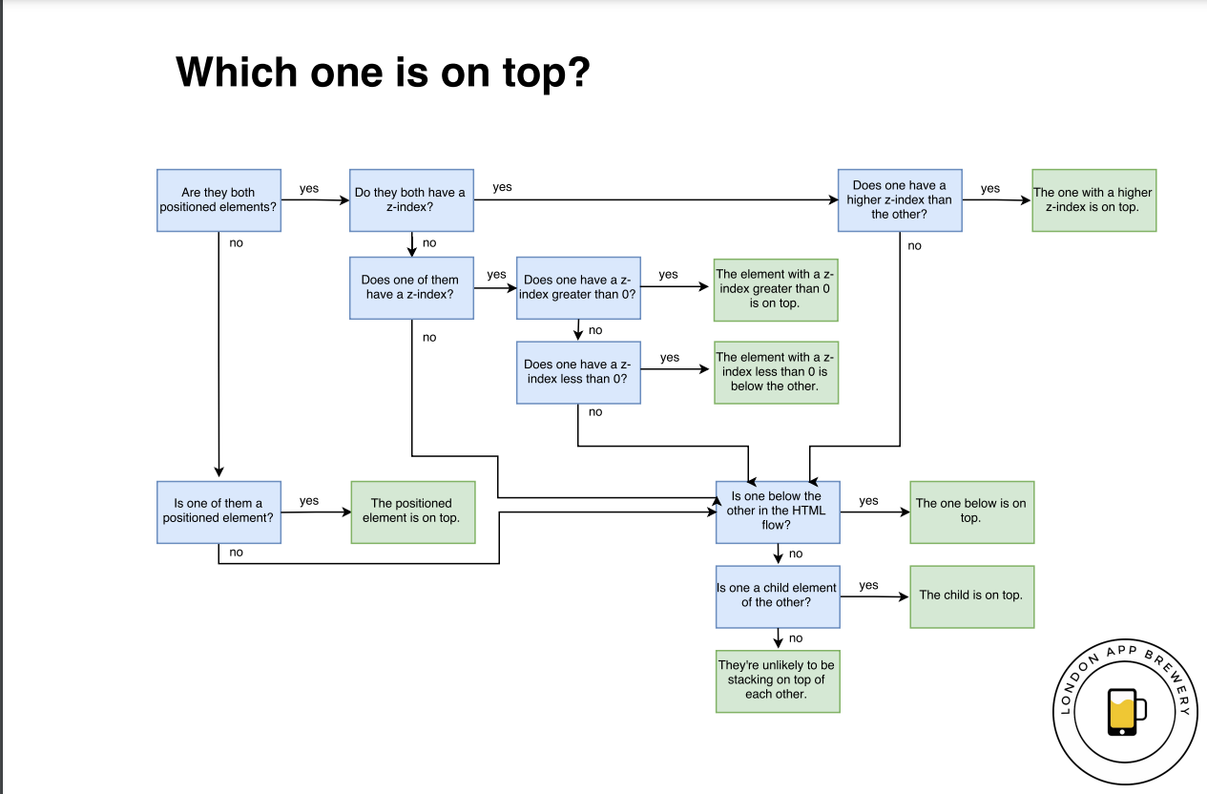

* To see, how mobile-friendly your website is, go to this URL: <https://search.google.com/test/mobile-friendly>
* **“Media Queries”** can be used to make your website more responsive e.g. **“media print[ … ]”**, **“@media screen[ … ]”**, or **“@media speech[ … ]”**etc.Format is **“@media <type> <feature>”** e.g.

@media (min-width: 768px) and (max-width: 1080px) {

  .bd-placeholder-img-lg {

    font-size: 3.5rem;

  }

}

* We can target a section on the page via the use of **“#”** in the *href* section *<a>* tag. It works in the URL level, or as an href.
* You need to tidy up your code in such a way that there is as less repetition as possible.
* How to refactor the code:
  + Readability
  + Modularity
  + Efficiency
  + Length
* **Parent Child { … }** can be used to combine the selectors and more selectors if required.
* **Id** is given the highest priority over everything else.
* **Id > class > tags**
* **Inline styles > internal styles**
* Use *“ids”* when you definitely need it.
* Try and keep as less classes as possible.
* Try your very best to not use inline styles.

**Day 59: Blog Capstone Project Part 2 - Adding Styling**

* <https://www.creative-tim.com/bootstrap-themes/free> , this website will have bootstrap themes and examples also.

**Day 60: Make the Contact Form Work**

* To make a form and to get the information of your username and password, following code is an example:

from flask import Flask, render_template, request

@app.route("/login", methods = ["POST", "GET"])

def recieve_data():

    name = request.form["username"]

    password = request.form["password"]

    return f"<h1>Username: {name}, Password: {password}</h1>"

* And for HTML code, here it is, username is the name of that input that identifies it:

<form action="/login" method="post">

<label for="">Name</label>

<input type="text" placeholder="Salman Adnan" name="username">

    <label for="">Password</label>

    <input type="password" placeholder="********" name="password">

    <button type="submit">Submit</button>

</form>

**Day 61: Building Advanced Forms with Flask-WTForms**

* **Flask WTF** forms are an advanced version of **Flask** forms and can make typing super simple.
* Documentation of **Flask WTF**: <https://flask-wtf.readthedocs.io/en/1.0.x/>
* To make **flask wtf** forms, you first need to import the classes required, then create the form in the class e.g.

from flask_wtf import FlaskForm

from wtforms import StringField, PasswordField, SubmitField

from wtforms.validators import DataRequired, Email, Length

class LoginForm(FlaskForm):

    email = StringField(label='Email', validators=[DataRequired(), Email()])

    password = PasswordField(label='Password', validators=[DataRequired(), Length(min=8)])

    submit = SubmitField(label="Log In")

* **Validators** in the above code in the class will specify, what need to validated, and things to be validated are written in a list.
* **Wtforms** can be used to ease the verification workflow, and they are not specific to Flask.
* Documentation of wtforms: <https://wtforms.readthedocs.io/en/2.3.x/>
* Writing **“, methods=[“GET”, “POST”]”**, right after the route, means that either you want to redirect to a website or you are receiving some data.
* By writing **“novalidate”** at the end of an *HTML tag*, means that browser specified styles will not apply, rather, python specified styles will.
* To get the data of the form after clicking submit would be done as **“login_form.<variable_name_in_class>.data”** e.g.

if login_form.email.data == "admin@email.com" and login_form.password.data == "12345678":

            return render_template("success.html")

* For HTML code, you can pass in that class and then use it like this:

<!DOCTYPE HTML>

<html>

    <head>

        <title>Login</title>

    </head>

    <body>

        <div class="container">

            <h1>Login</h1>

            <form method="POST" action="{{ url_for('login') }}">

                {{ form.csrf_token }}

                <p>

                {{ form.email.label }} <br> {{ form.email(size=30) }}

                </p>

                <p>

                {{ form.password.label }} <br> {{ form.password(size=30) }}

                </p>

                {{ form.submit }}

            </form>

        </div>

    </body>

</html>

* Here, we specify the labels and their input boxes by the use of the variables used in the class of python
* **CSRF (Cross-site Request Forgery)** is used to authenticate those users who are not authenticated.
* **“form.submit”** will make a submit button and then as soon as it pressed the data will be sent to the location we want it to get sent.
* If some part of the file is repetitive, we can write that part in another file and then use that file where required via the following command:

{% include "header.html" %}

* If in case, you need to inherit the data that was used before it, you can use:

{‌{ super() }}

* The following code:

{% extends "base.html" %}

* Would mean that, now you can change some parts of that file also.
* In general, a template prepared as a bootstrap version, so we can use that template to do out work e.g.:

{% extends 'bootstrap/base.html' %}

{% import "bootstrap/wtf.html" as wtf %}

{% block title %}

Login

{% endblock %}

{% block content %}

<div class="container">

    <h1>Login</h1>

    {{ wtf.quick_form(form) }}

</div>

{% endblock %}

* In the above code, 2nd line, we are importing **“bootstrap/wtf.html”** because, instead of writing every single line and for the form, we can instead use **“quick_form”**.
* To extend **bootstrap/base.html**, you need to initialize that in the file of python from where it is called like this:

from flask_bootstrap import Bootstrap

Bootstrap(app)

* Documentation for **“Flask-Bootstrap”** <https://pythonhosted.org/Flask-Bootstrap/basic-usage.html>

**Day 62: Flask, WTForms, Bootstrap and CSV - Coffee & Wifi Project**

* To make a table using **Flask**, do this:

<table class="table">

        {% for row in cafes: %}

          <tr>

            {% for item in row: %}

              {% if item[0:4] == "http" %}

                <td><a href="{{ item }}" target="_blank">Maps Link</a></td>

              {% else %}

                <td>{{ item }}</td>

              {% endif %}

            {% endfor %}

          </tr>

        {% endfor %}

      </table>

* We can store the data of the **quickform** in an **excel csv file** via this:

with open("cafe-data.csv", mode="a", encoding="utf-8") as csv_file:

            csv_file.write(f"\n{form.cafe.data},"

                           f"{form.cafe_link.data},"

                           f"{form.opening_time.data},"

                           f"{form.closing_time.data},"

                           f"{form.coffee_rating.data},"

                           f"{form.wifi_rating.data},"

                           f"{form.power_rating.data}")

**Day 63: Creating a Virtual Bookshelf**

* Another way of storing data is by making an **“SQL Database”**.
* This can be done by two methods:
  + **sqlite3**
  + **sqlalchemy** (Simpler)
* For **sqlite3**:

import sqlite3

* + First import the module.
  + To create the database, use the command **“.connect(“<database_name>”)”**:

db = sqlite3.connect(database="book-collection.db")

* + Now, you need to make the cursor which will navigate through the file and create the table for it:

try:

    cursor.execute("CREATE TABLE books (id INTEGER PRIMARY KEY, title varchar(250) NOT NULL UNIQUE, author varchar(250) NOT NULL, rating FLOAT NOT NULL)")

except sqlite3.OperationalError:

    pass

* + Where **“CREATE TABLE <table_name>”** will make the table and **“id”** will define a column which will be identified uniquely.
  + **“NOT NULL”** is used to tell that the field should not be left empty.
  + **“UNIQUE”** tells that every item in that column should be unique.
  + **DISCLAIMER:** *Every single letter and word matters, one mistake and your program may not work*.
  + To insert the data in the table, you can use **“<database_name>.execute(INSERT INTO <table_name> VALUES(<all_the_values>)”**, then using **“<database_name>.commit”**:

cursor.execute("INSERT INTO books VALUES(1, 'Harry Potter', 'J. K. Rowling', '9.3')")

db.commit()

* + Other commands for **.execute** that could potentially be use are listed in this website <https://www.codecademy.com/article/sql-commands>
  + Since, doing this whole thing can be cumbersome, you can use **sqlalchemy** to make things simpler.
* For **sqlalchemy**:
  + Documentation for Flask SQLAlchemy: <https://flask-sqlalchemy.palletsprojects.com/en/2.x/>
  + First and foremost, import it:

from flask_sqlalchemy import SQLAlchemy

* + Then, to create the database, use “**app.config['SQLALCHEMY_DATABASE_URI'] = "sqlite:///<databse_name>.db"”**

app.config['SQLALCHEMY_DATABASE_URI'] = "sqlite:///books.db"

* + You could get a **depreciation warning**, so, to avoid that use this:

app.config['SQLALCHEMY_TRACK_MODIFICATIONS'] = False

* + To then create the table, use the library **“SQLAlchemy”**:

db = SQLAlchemy(app)

* + To then, create the table, you need to use the class like this:

##CREATE TABLE

class Book(db.Model):

    id = db.Column(db.Integer, primary_key=True)

    title = db.Column(db.String(250), unique=True, nullable=False)

    author = db.Column(db.String(250), nullable=False)

    rating = db.Column(db.Float, nullable=False)

with app.app_context():

    db.create_all()

* + Here, it is almost the same, except, it has become much simpler.
  + While declaring the class, pass **“<database_name>.Model”** as the parameter of the class.
  + To write a record, you can use:

new_book = Book(id=1, title=request.form["title"], author=request.form["author"], rating=request.form["rating"])

db.session.add(new_book)

db.session.commit()

* + Here, you simply use the class you have created earlier on i.e. **Book**, then, you append that data in the original database via the use of **“<database_name>.session.add(<record_name>)”**.
  + After, all the records has been added or updated or whatsoever, you use **“<database_name>.session.commit()”**.
  + With *SQLAlchemy*, you can do **“CRUD (Create Read Update Delete)”**
  + For creating the record, we already discussed it.
  + For reading the records, you can read:
    1. all the records by **“<database_name>.session.query(Book).all()”** and store them in a variable e.g.

all_books = db.session.query(Book).all()

* + 1. read a particular record by **“book = Book.query.filter_by(title="Harry Potter").first()”**.
  + For updating the record, you can update:
    1. a record by query:

book_to_update = Book.query.filter_by(title="Harry Potter").first()

book_to_update.title = "Harry Potter and the Chamber of Secrets"

db.session.commit()

* + 1. a record by primary key:

book_id = 1

book_to_update = Book.query.get(book_id)

book_to_update.title = "Harry Potter and the Goblet of Fire"

db.session.commit()

* + For deleting the record by primary key:

book_id = 1

book_to_delete = Book.query.get(book_id)

db.session.delete(book_to_delete)

db.session.commit()

* If **“url_for()”** is used and an argument is passed, so, you can get that argument by this also:

book_id = request.args.get('id')

* In order to use **“url_for”** and **“redirect”** in a python file with **“@app.route(“/<route>”)”**, you need to use **“methods=[“GET”]”** after the route.

**Day 64: My Top 10 Movies Website**

* You can order the column according to a certain value e.g. according to rating via the use of **“.order_by(<database_class>.<element>)”** e.g.:

@app.route("/")

def home():

    all_movies = db.session.query(Movie).order_by(Movie.rating).all()

    return render_template("index.html", movies=all_movies)

* This is the website we used for today’s project: <https://developers.themoviedb.org/3/getting-started>
* More documentation on sqlalchemy and databases: <https://docs.sqlalchemy.org/en/13/orm/query.html#sqlalchemy.orm.query.Query.order_by>

**Day 64: Web Design School - How to Create a Website that People will Love**

* Full Jinja Documentation: <https://jinja.palletsprojects.com/en/2.11.x/templates/>

**Day 65: Web Design School - How to Create a Website that People will Love**

* Four web design principles:
  + Color Theory
  + Typography
  + User Interface
  + User Experience Design
* **Color Theory:**
  + You have to be aware of your color palettes
  + **Red:** Love, energy, and intensity
  + **Yellow:** Joy, intellect, and attention
  + **Green:** Freshness, safety, and growth
  + **Blue:** Stability, trust, and serenity
  + **Purple:** Royalty, wealth, and femininity
  + By mixing up multiple colors, you create what’s **“Analogous Colors”**, and design with these kinds of colors look incredibly harmonious and look pretty well.

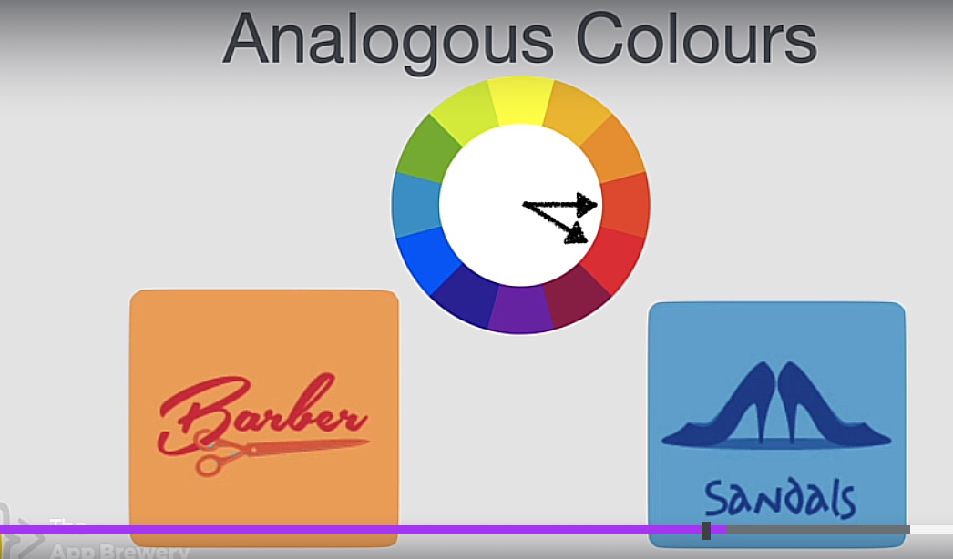

* + If you want something standing out, you should take colors from opposite ends which are called **“Complementary Colors”**

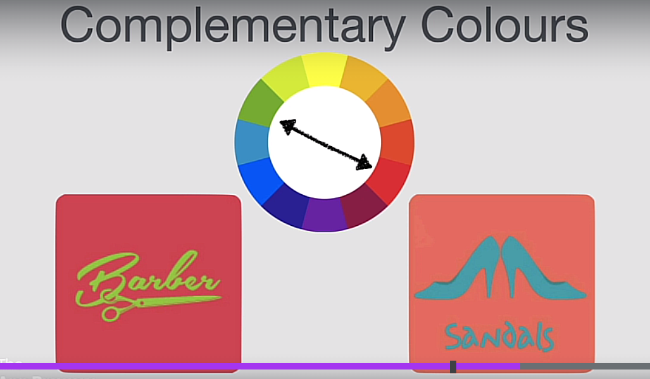

* + Don’t try to style text and its background with it. Keep it with logos and stuff
  + To explore these kinds of colors, head over to this website: <https://color.adobe.com/create/color-wheel> or <https://colorhunt.co>
* **Typography:**
  + Fonts matter e.g. in *Eid Mubarak*, if you write in some bold and non-stylish font, it doesn’t look as good.
  + Two fonts you should know about: **serif** and
  + The thickness of your font matters, it tells how old the font is, so, for something to look authorities but modern, you want to go for a modern serif typeface.
  + Different fonts have different moods and emotions

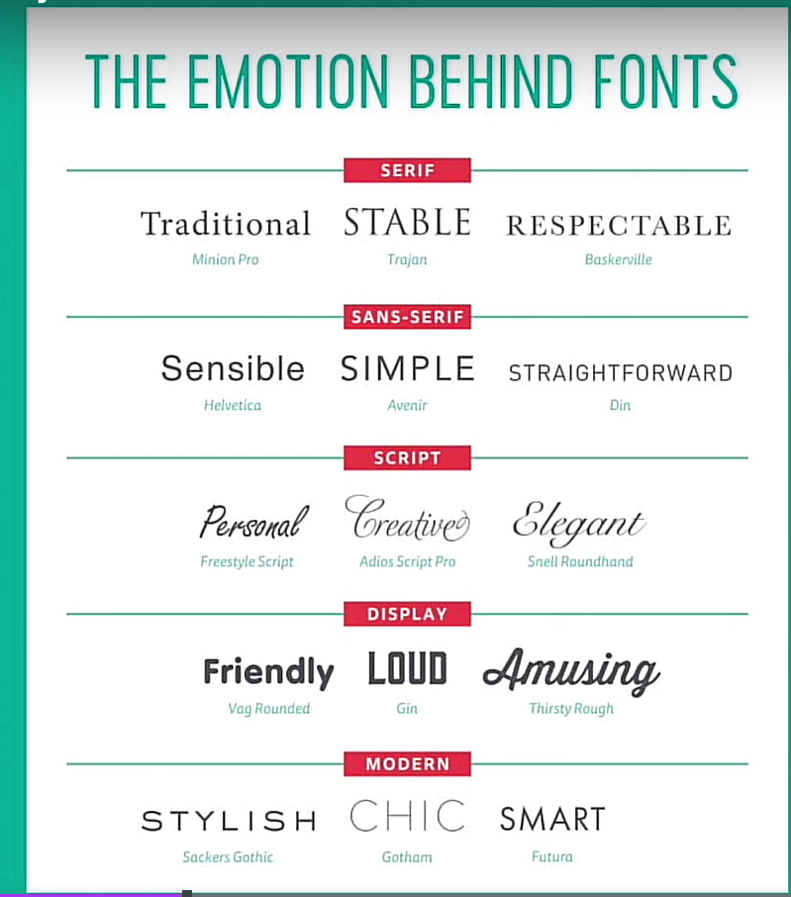

* + It also matters how much time you can save with certain type of font.
  + Keep the portion of your text up to two fonts.
  + Find fonts that have similar moods and those with contrast moods.
* **User Interface (UI):**
  + Your **color contrast** matters e.g. if the colors are almost same, it would feel like they are of equal importance but with contrast, you can understand their importance.

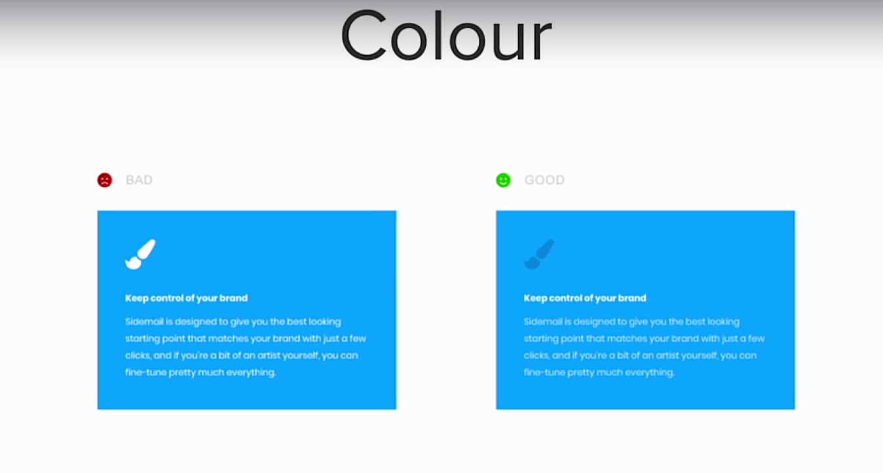

* + **Size** also matter since bigger items tend to attract your attention early on.

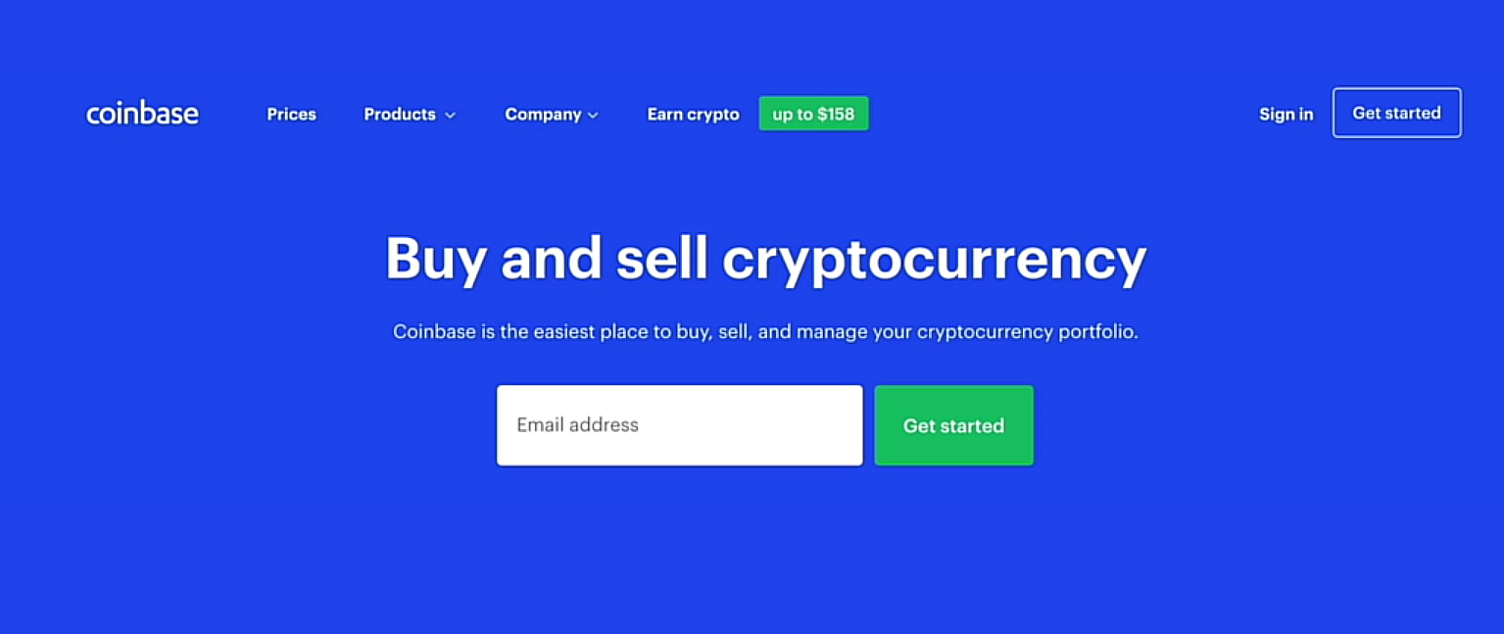

* + **Layout** also matters e.g. if a website has everything just laid out similarly compared to a website with different images, sizes, and fonts would look more interesting e.g. Wikipedia look pretty bland or Grammarly that looks pretty good

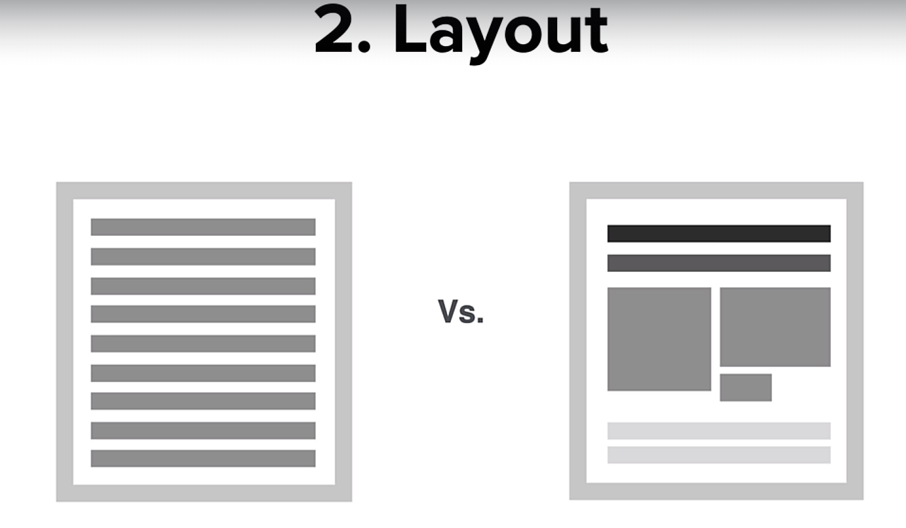

* + **Alignment** matters

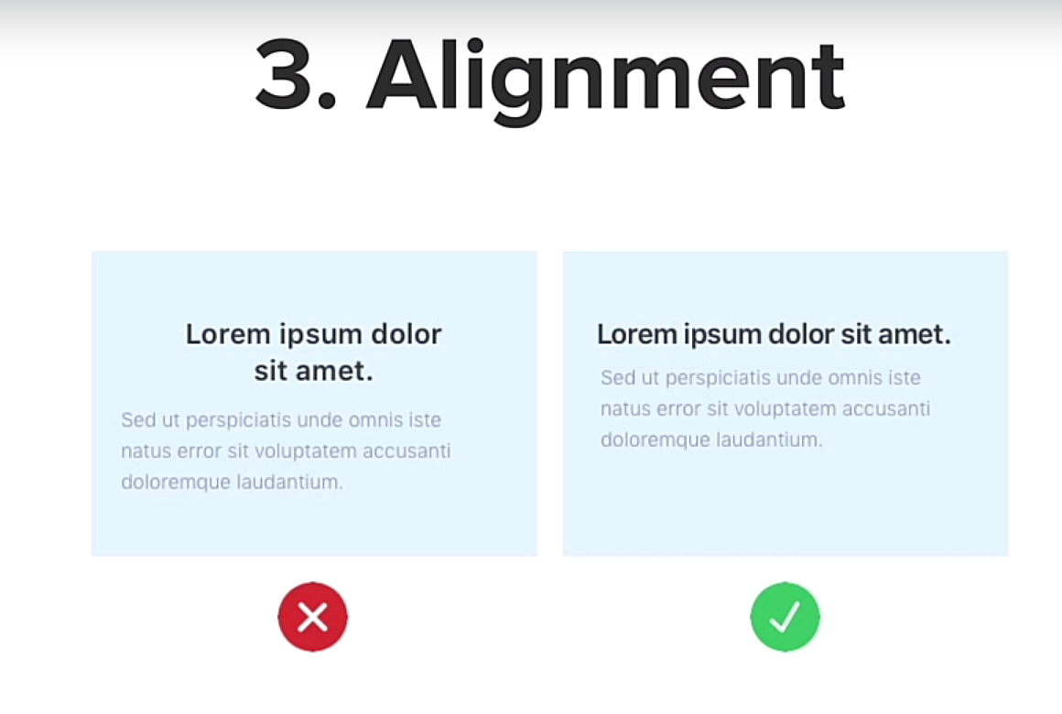

* + You can gridlines to help you out e.g.

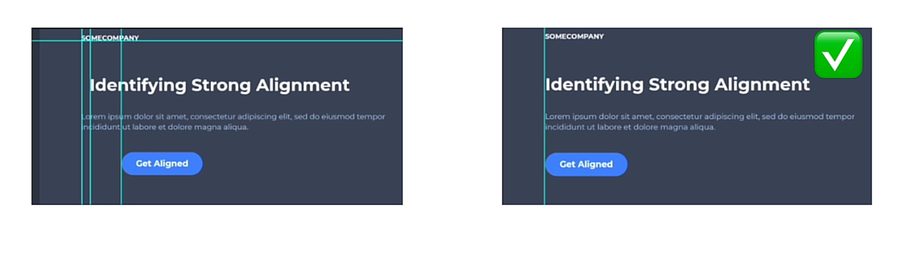

* + By spacing things out, and not making it too filled could potentially e.g. luxury designer stores vs random street designer shop.
  + You want to make your website depending on the type of **audience** you want to have e.g. the following one for children

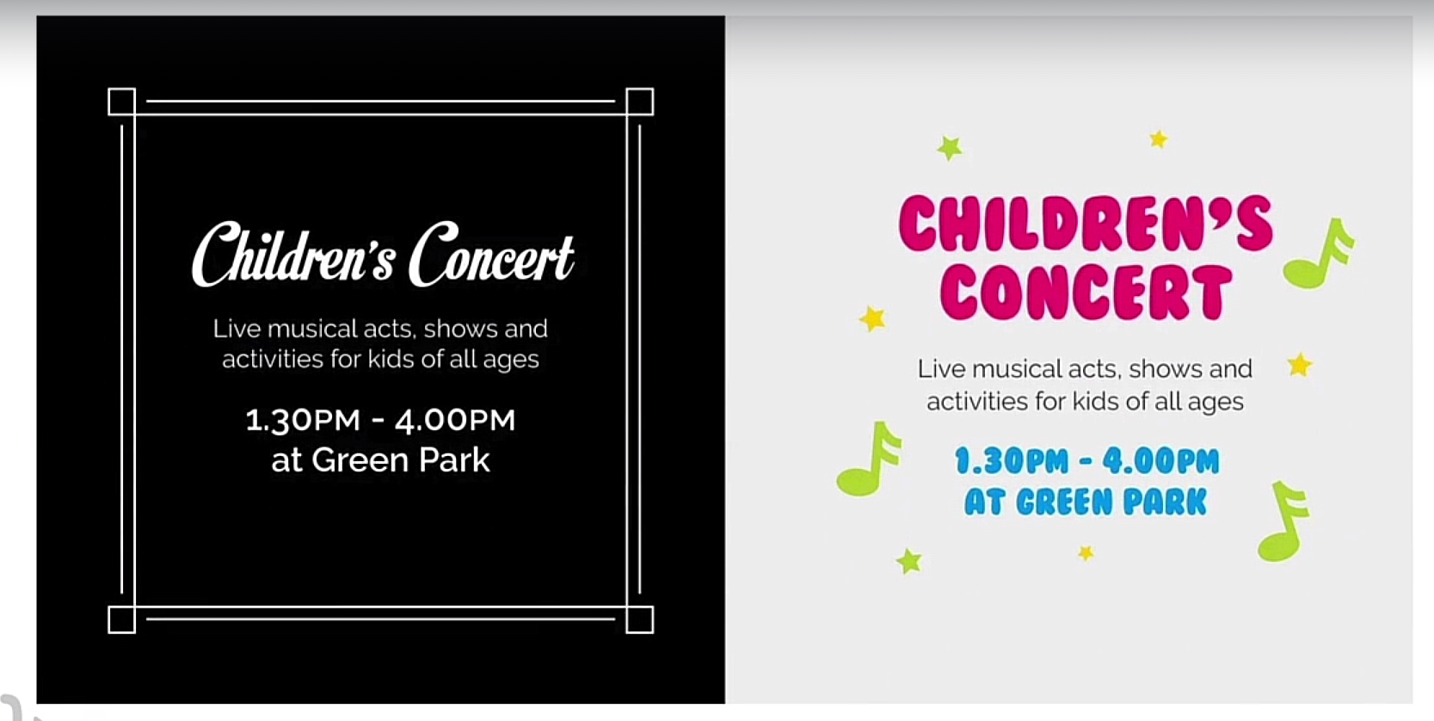

* **User Experience (UX):**
  + Design is what looks good and what you want to force on the user while user experience is **invisible**, it’s meant to be effortlessly easy and just let you do your thing.

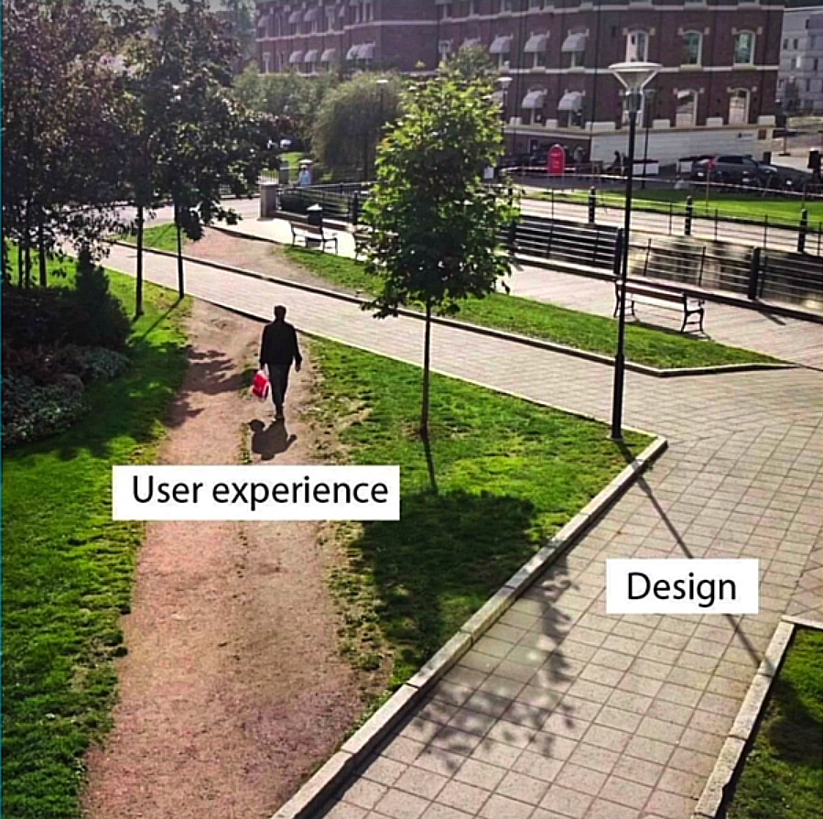

* + To do so, we have to think about five things:
    1. **Simplicity**, your website needs to be simple e.g. following one is not good and the one after that is:

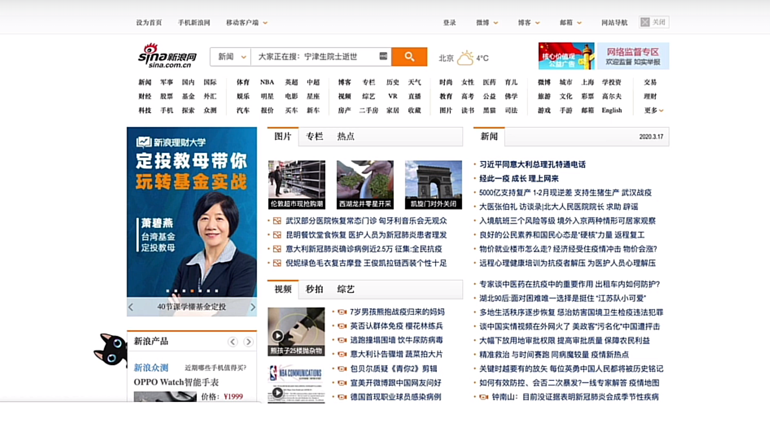 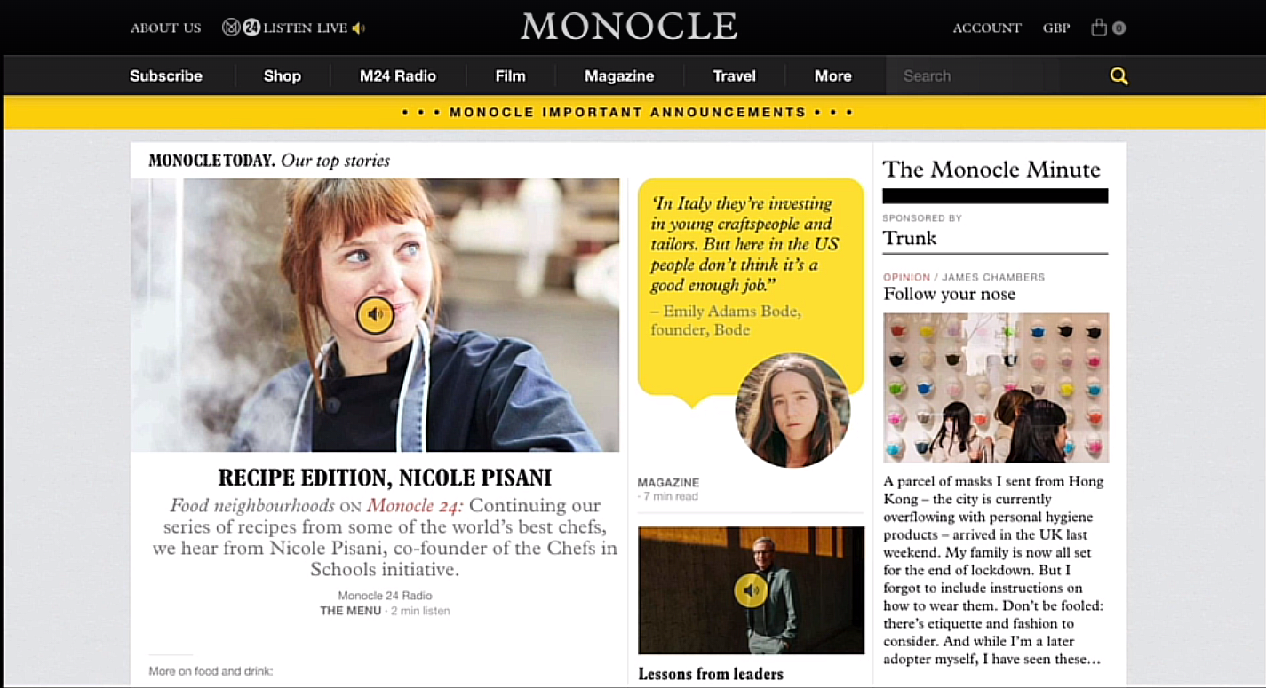

* + 1. Always try to pair it down.
    2. **Consistency:** It matters e.g. following website doesn’t look enough good

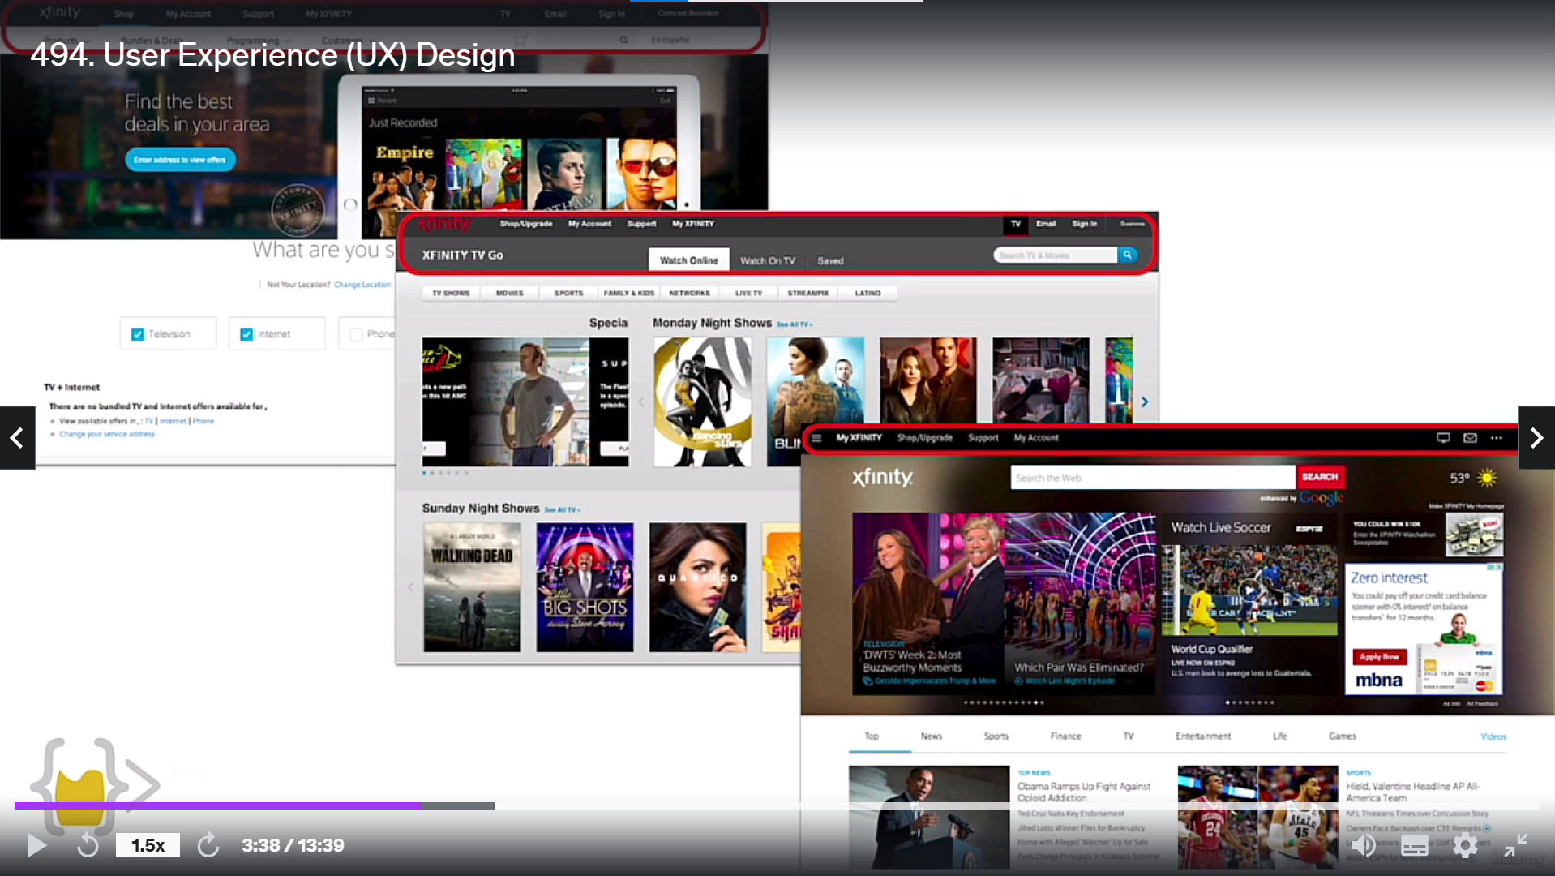

* + 1. **Reading Patterns:** Design your website in a way that it matches general user reading patterns e.g. the most common website is *F-pattern* e.g.

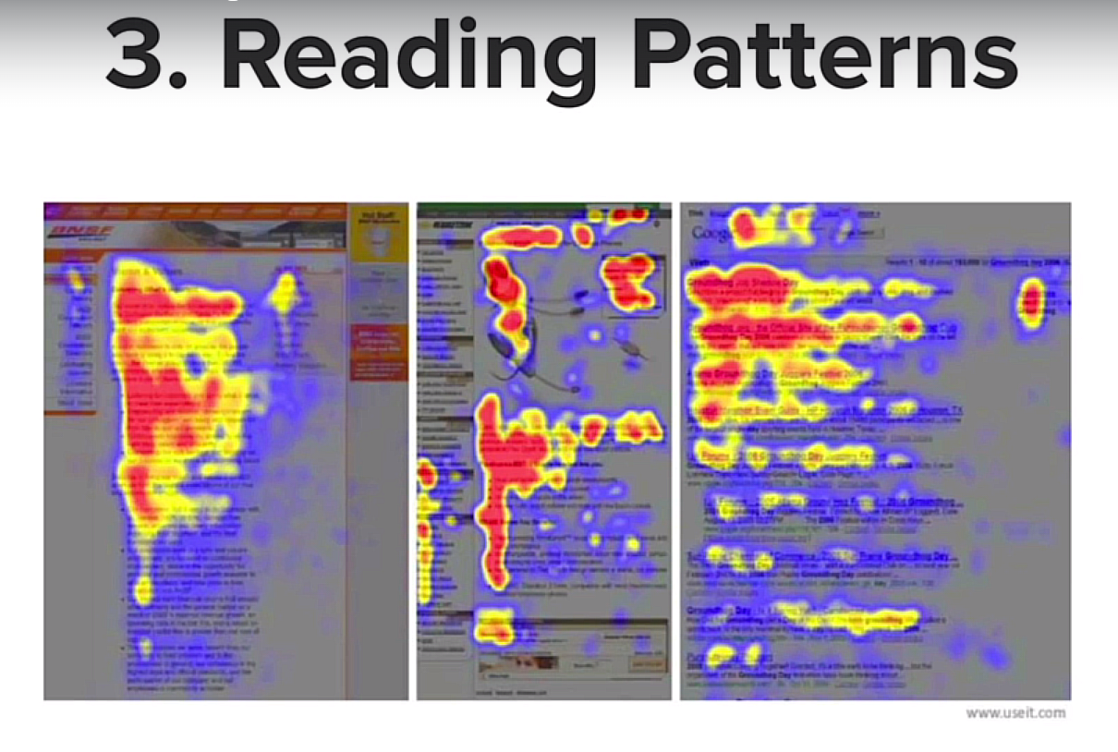

* + 1. Or the *Z-layout* e.g.

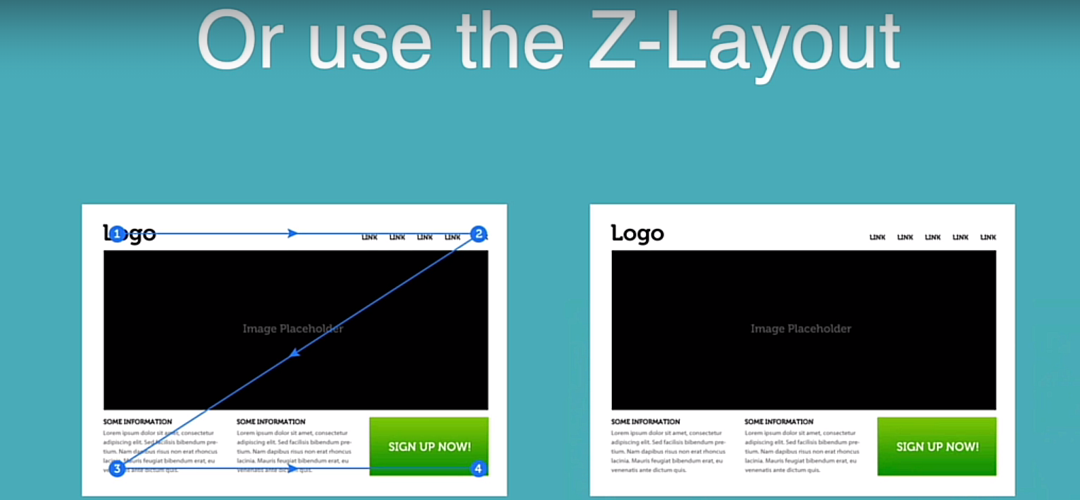

* + 1. The type of layout also depends on your website’s functionality e.g. Z-layout is used for websites which are sparser (thinly scattered or distributed), more video content, or browse through the website a little bit faster e.g.

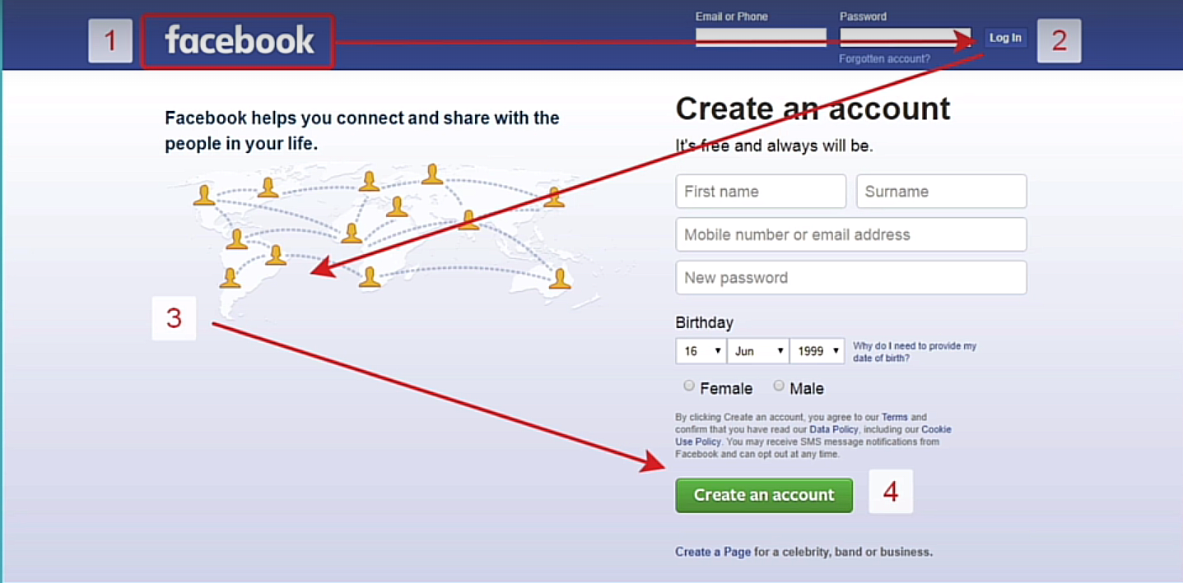

* + 1. **All platform design:** You have to think your website for mobiles also which is also known as mobile responsive e.g.

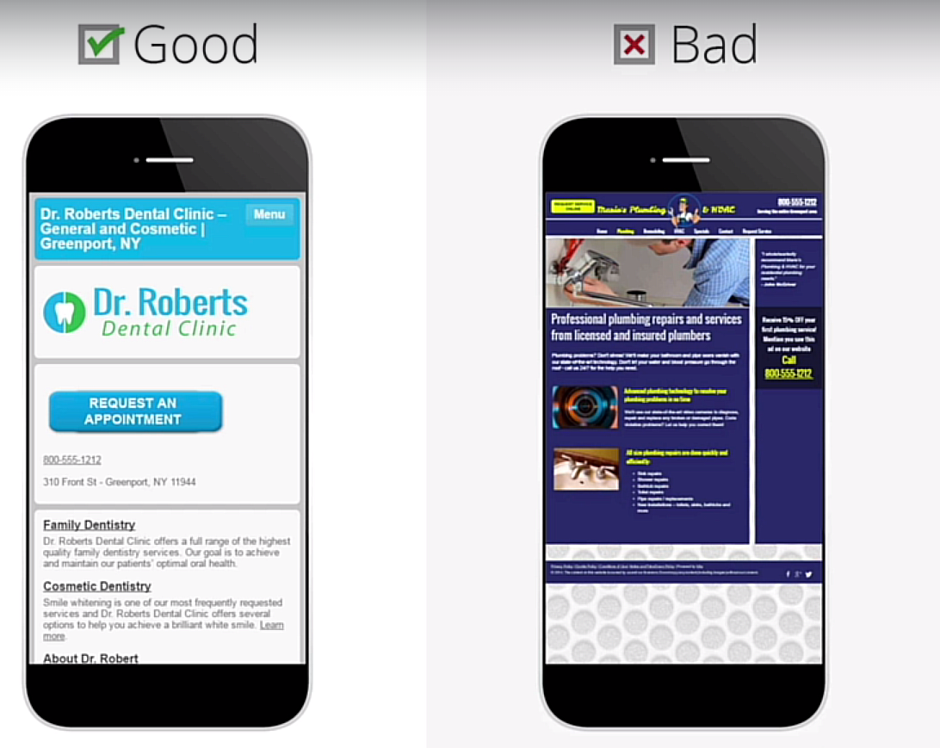

* + 1. Banners avoid website to be scrolled through, they can make your look a lot smaller e.g. most of the screen covered with banners and that doesn’t mean you should go crazy like just one thing.
    2. **Dark Patterns (Don’t use your powers for *Evil*):** Don’t design websites that can make the user perform an action that benefits the company and not the user necessarily e.g.

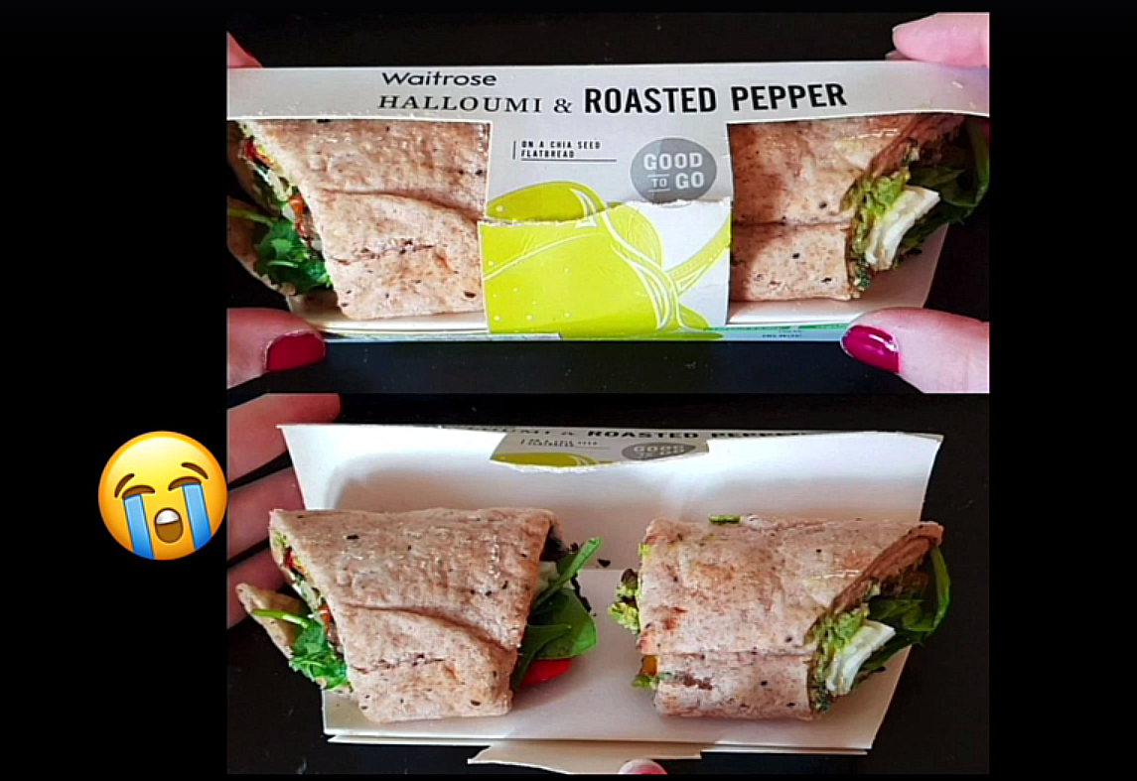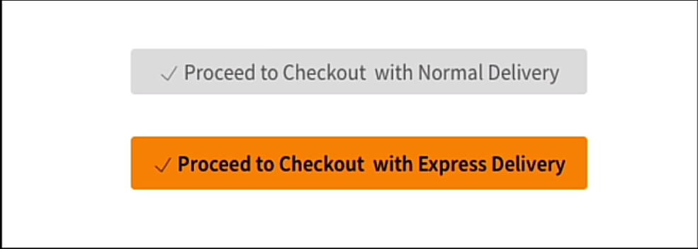

* + 1. Or this one where the user has tried to put in hair kind so when the user tries to remove it, they actually click it

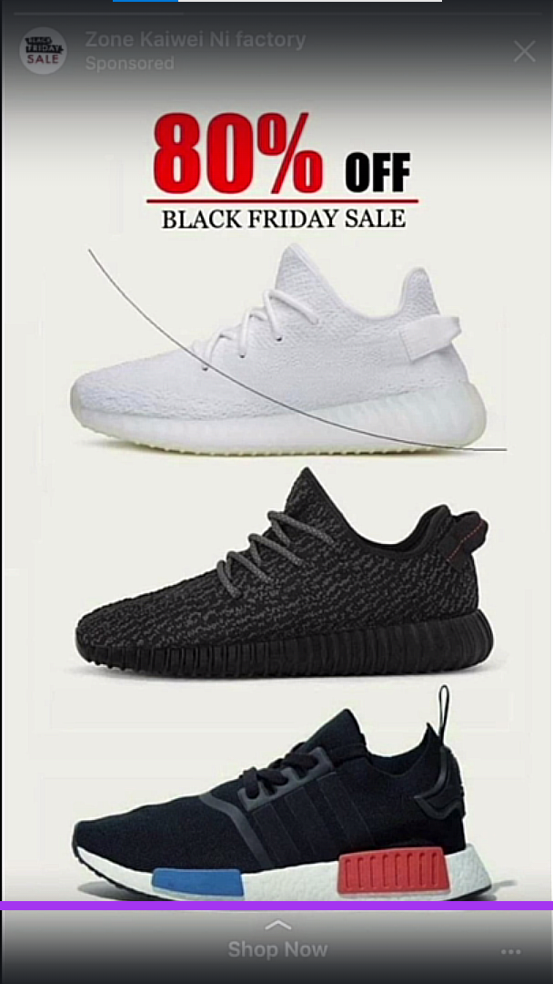

* + 1. It can be done by using dropdown boxes or text e.g. (Don’t Insure Me option)

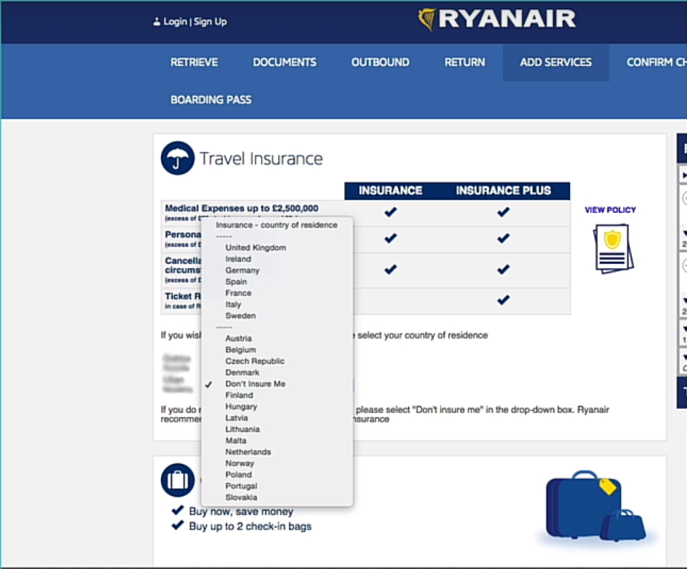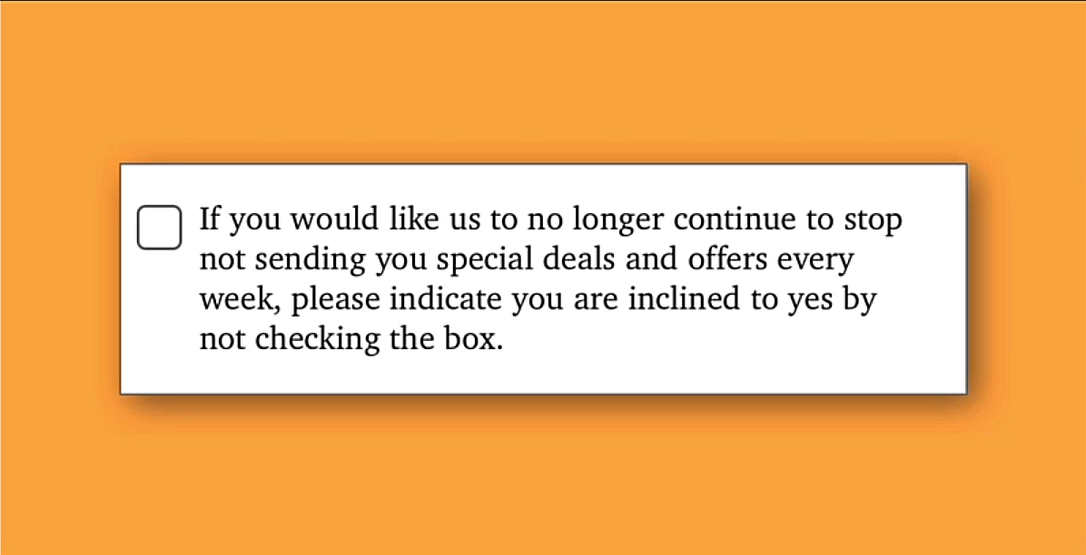

* **Web Design Principles:**
  + This website can significantly help you in improving your web design: <https://www.dailyui.co>
  + This one also: <https://collectui.com>
  + You can design your website using: <https://www.canva.com>
  + Basic website on Canva: <https://www.canva.com/design/DAFgu2iebjo/nj1pHCAgXUa3ooIv6UKQzQ/view?website#4:hotel>
  + Link to the template on Canva: <https://www.canva.com/design/DAFgu2iebjo/FP1GC2nRTWAtN-gIf0HkBw/edit?utm_content=DAFgu2iebjo&utm_campaign=designshare&utm_medium=link2&utm_source=sharebutton> (Account: grmculmfuer9 (Gmail))

**Day 66: Building Your Own API with RESTful Routing**

* **REST** stands for **“Re**presentational **S**tate **T**ransfer**”**
* When a *client* makes a request to the *server*, it happens via the use of **HTTP (HyperText Transfer Protocol)**
* Servers can also understand other languages e.g. **FTP (File Transfer Protocol)** etc…
* **HTTPS** stands for **HTTP Secure**
* When a request is made to the server, two things server may need to do i.e. either computation or access the database
* **API (Application User Interface)** is the link between the client and the server just like a waiter in a restaurant that is the link between the client (customer) and server (chef)
* Some of the styles that were used before **REST** *API* style were e.g. **SOAP (Simple Object Access Protocol)**, **Graph (Graph Query Language)**, and **FALCOR**
* **PUT** vs **PATCH**
  + **PUT** means that the entire data entry will be replaced
  + **PATCH** means that a part of data entry will be replaced

**Day 67: Blog Capstone Project Part 3 - RESTful Routing**

* If you want to change the color of your button in wtf forms, do this:

{{ wtf.quick_form(form, novalidate=True, button_map={"submit": "primary"}) }}

* If you want to add a styling field to any of your input field i.e. make the text bold, bullet points etc, do this:

{{ ckeditor.load() }}

{{ ckeditor.config(name="body") }}

* To show the post content directly from the class in HTML code, you may not get the styling i.e. *<ol>* or *<em>* etc, so, do this:

{{ post.body|safe }}

**Day 68: Login and Registering Users with Authentication**

* Notes left !

**Day 69: Blog Capstone Project Part 4 - Adding Users**

* Done!

**Day 70: Your Web Application with Heroku**

* **GitBash Commands:**
  + **“cd <foldername>”** to enter a folder in the current directory
  + **“ls”** or **“dir”** to know about the folder in the current directory
  + **“cd”** to go back to the root folder
  + **“touch <filename.extension>”** to create the file
  + **“start <filename.extension>”** to open the file
  + **“clear”** to clear the console
  + **“vim <filename.extension>** to open that file in GitBash
    1. **“:wq”** to save and exit
    2. **“:q!”** to exit
    3. **“:wqa”** to save and exit multiple files
  + **“git init”** to initialize git repository
  + **“ls -a”** to know the file contents of this repository
  + **“git status”** to know which files are committed and which not
  + **“git add <filename.extension>”** in the stage of committing that file to the repository or **“git add .”** to commit everything in that file
  + **“git commit -m “<message for the commit>””** to commit the changes done by **git add**. (Using present tense is better)
  + **m** in **“-m”** means message
  + **“git log”** to track the commits you have made
  + **“Head”** after one of the *git log* status means you are at the current stage
  + 4 stages of committing the file to the Github repository:
    1. **Working Directory:** This is where you are editing and making changes to your file
    2. **Staging Area:** Stage right before you commit your changes so you can know that what you want to commit and what not
    3. **Local Repository:** All the files have been either committed or stored in the repository
    4. **Remote Repository:** All files are committed to the remote repository online
  + **“git diff <filename.extension”** to know what changes you have made before committing or staging
  + **“git checkout”** will revert the changes to the last commit that was made to the repository
  + **“git remote add origin <url>”** to add an online Github repository where you will commit the changes online
  + **“git branch -M <branch_name>”** to set main branch name to branch_name
  + **“git push -u <remote_branch_name> <branch_name>”** to update those changes online to the Github repository to branch_name from remote_branch_name

**Day 71: Data Exploration with Pandas: College Major v.s. Your Salary**

* In pandas:
  + **“df.head()”** gives first 5 elements
  + **“df.tail()”** gives last 5 elements
  + **“df.shape”** gives number of rows and columns
  + **“df.columns”** gives all the column names as a list
  + **“df.isna()”** to give columns with NaN (Not a Number) values where the data isn’t present
  + **“df.dropna()”** would delete the last row
  + **“df[column_name].max()”** will give the maximum value in that column
  + **“df[column_name].idxmax()”** will give the id of the maximum value in that column
  + **“df[column_name].idxmin()”** will give the id of the minimum value in that column
  + **“df.loc[row_value][column_name]”** would give the value of that particular cell
  + **“df[column_name][row_value]”** would give the value of that particular cell
  + **“df[column_name] – df[column_name]”** or **“df[column_name].subtract(df[column_name])”** would give the column with subtracted values of both columns
  + **“df[column_name]****[row_number] – df[column_name] [row_number]”** or **“df[column_name[row_number]].subtract(df[column_name] [row_number])”** would give a single value which is a result of subtraction
  + **“df.insert(column_number, “column_to_be_made_name”, column_to_be_used)”** to insert a new column in the table
  + **“df.sort_values(by, ascending=True, inplace=False, kind='quicksort', ignore_index=False)”** to sort the values where:
    1. **“by”** is the str or list of str for ordering
    2. **“inplace”** if true would change actual dataframe
    3. **“kind”** means type of algorithm
    4. **“ignore_index”** if true wouldn’t tell actual indexes after ordering the dataframe
    5. **“na_position”** if first would place the NaN at beginning and if last would place them at last
  + **“df.groupby(column_name)”** will group the dataframe according to that column e.g. first STEM then HASS then Business rows
  + **“df.groupby(column_name).count()”** same as above but it will give the count of each group
  + **“df.groupby(column_name).mean()”** same as one before the previous one but it will give mean for every column individually in the order of groups
  + **“pd.options.display.float_format = '{:,.2f}'.format”** will change the format to including commands in the float number where appropriate and round it to 2 decimal places

**Day 72: Data Visualization with Matplotlib: Programming Languages**